LAB EXPERIMENTS – ITA04 STATISTICS WITH R PROGRAMMING
1. Create numeric, character, and logical vectors and display type and content. 2. Create labeled matrices (5×4, 3×3, 2×2) filled by row/column.
3. Write an R program to create and display a 3D array with specified rows, columns, and tables. 4. Create arrays from vectors with dimension names, print specific elements. 5. Create and manipulate factor variables (e.g., women’s dataset heights, random LETTERS sample). 6. Create an R list containing vectors, matrices, and functions; display contents. 7. Write R programs for basic tasks: Factors of a number, generate a vector of 10 random integers between -50 and 50, print numbers 1–100 with FizzBuzz logic.
8. Generate random numbers from a normal distribution; count occurrences. 9. Create empty plots with specified axis limits.
10. Create and explore a data frame exam_data with name, score, attempts, and qualify fields. Perform extract, add row/column, sort, save to file.
11. Write an R program to read a .csv file and display contents.
12. Perform data reshaping on airquality dataset: melt, cast, compute monthly averages for Ozone, Solar.R, Wind, and Temperature.
13. Combine multiple arrays row-wise.
14. Explore and manipulate ChickWeight dataset (sorting, melting, casting by Diet). 15. Perform EDA on iris dataset: dimensions, summary, standard deviation, quantiles, grouping by Species, pivot table, categorical grouping with Sepal.Length categories.
16. Explore USArrests dataset: summary statistics, state with largest rape arrests, max & min murder rates, correlation among features, states above median assault arrests and bottom 25% for murder, visualization with histogram, density, scatterplots, bar graphs.
17. Explore Titanic dataset: bar chart of survival vs class, modify plot by gender, histogram of Age. 18. Create graphs in R: boxplot, histogram, bar plot, line chart, scatter plot.
19. Build a regression model on advertising dataset (Sales ~ Spend) and predict Sales. 20. Create multiple regression model using ChickWeight dataset with “Time” and “Diet” as predictors; predict weight and compute model error.
21. Randomly split iris dataset into train/test (80/20), build logistic regression (Species ~ Petal.Length + Petal.Width), predict, and evaluate with confusion matrix.

Experiment 1: Vectors

Question
1. Create numeric, character, and logical vectors and display type and content.

Code
num_vec <- c(10, 20.5, 30, 40)
chr_vec <- c("R", "Python", "Java")
log_vec <- c(TRUE, FALSE, TRUE)

cat("Numeric vector :", num_vec, "\n")
cat("Type:", typeof(num_vec), "| Class:", class(num_vec), "\n\n")

cat("Character vector :", chr_vec, "\n")
cat("Type:", typeof(chr_vec), "| Class:", class(chr_vec), "\n\n")

cat("Logical vector :", log_vec, "\n")
cat("Type:", typeof(log_vec), "| Class:", class(log_vec), "\n")

Output
Numeric vector : 10 20.5 30 40
Type: double | Class: numeric

Character vector : R Python Java
Type: character | Class: character

Logical vector : TRUE FALSE TRUE
Type: logical | Class: logical

Output Screenshot
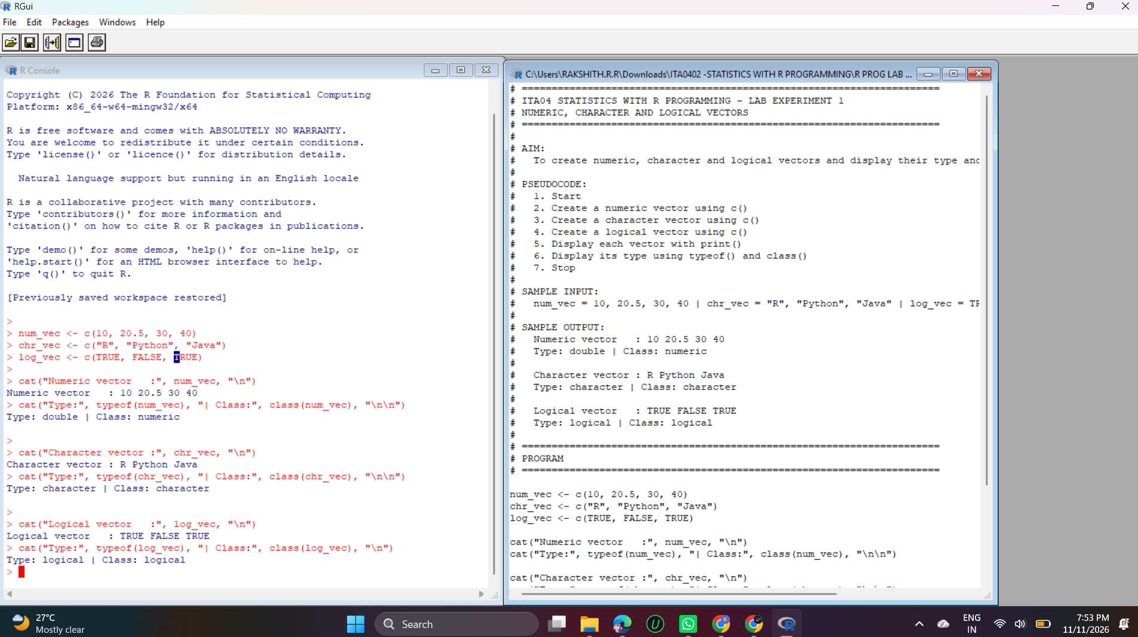
Output – Experiment 1

Explanation
A vector is the basic data structure in R. The c() function combines values into a vector.
num_vec holds numbers, chr_vec holds text in quotes and log_vec holds TRUE/FALSE values.
typeof() shows how R stores the data internally (20.5 makes the numeric vector type “double”), and class() shows the object class (numeric, character, logical).
cat() prints the contents, so the output confirms the content and type of all three vectors.

Experiment 2: Labeled Matrices

Question
2. Create labeled matrices (5×4, 3×3, 2×2) filled by row/column.

Code
# 5 x 4 matrix filled BY ROW
m1 <- matrix(1:20, nrow = 5, ncol = 4, byrow = TRUE,
dimnames = list(c("R1","R2","R3","R4","R5"),
c("C1","C2","C3","C4")))
print("5 x 4 matrix (filled by row):")
print(m1)

# 3 x 3 matrix filled BY COLUMN
m2 <- matrix(1:9, nrow = 3, ncol = 3, byrow = FALSE,
dimnames = list(c("a","b","c"), c("x","y","z")))
print("3 x 3 matrix (filled by column):")
print(m2)

# 2 x 2 matrix filled BY ROW
m3 <- matrix(c(5, 10, 15, 20), nrow = 2, byrow = TRUE,
dimnames = list(c("Row1","Row2"), c("Col1","Col2")))
print("2 x 2 matrix (filled by row):")
print(m3)

Output
[1] "5 x 4 matrix (filled by row):"
C1 C2 C3 C4
R1 1 2 3 4
R2 5 6 7 8
R3 9 10 11 12
R4 13 14 15 16
R5 17 18 19 20
[1] "3 x 3 matrix (filled by column):"
x y z
a 1 4 7
b 2 5 8
c 3 6 9
[1] "2 x 2 matrix (filled by row):"
Col1 Col2
Row1 5 10
Row2 15 20

Output Screenshot
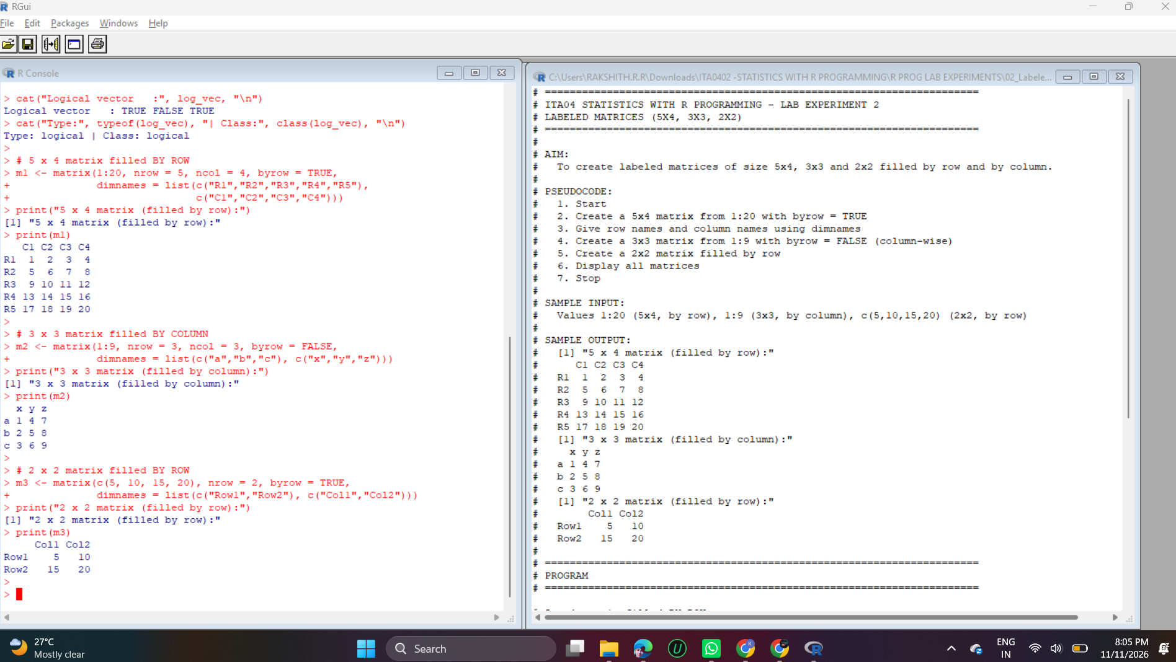
Output – Experiment 2

Explanation
matrix(data, nrow, ncol, byrow) builds a matrix. With byrow = TRUE the values are filled row by row (the 5×4 and 2×2 matrices); with byrow = FALSE, the default, they are filled column by column (the 3×3 matrix).
dimnames = list(row_names, column_names) labels the rows and columns, so the matrices print with names like R1–R5 and C1–C4 instead of [1,] and [,1].
The output shows 1–20 across the rows of the 5×4 matrix, 1–9 down the columns of the 3×3 matrix and 5, 10, 15, 20 across the rows of the 2×2 matrix.

Experiment 3: 3D Array

Question
3. Write an R program to create and display a 3D array with specified rows, columns, and tables.

Code
arr <- array(1:24, dim = c(4, 3, 2)) # 4 rows, 3 columns, 2 tables
print(arr)
cat("Dimensions of the array:", dim(arr), "\n")

Output
, , 1

[,1] [,2] [,3]
[1,] 1 5 9
[2,] 2 6 10
[3,] 3 7 11
[4,] 4 8 12

, , 2

[,1] [,2] [,3]
[1,] 13 17 21
[2,] 14 18 22
[3,] 15 19 23
[4,] 16 20 24

Dimensions of the array: 4 3 2

Output Screenshot
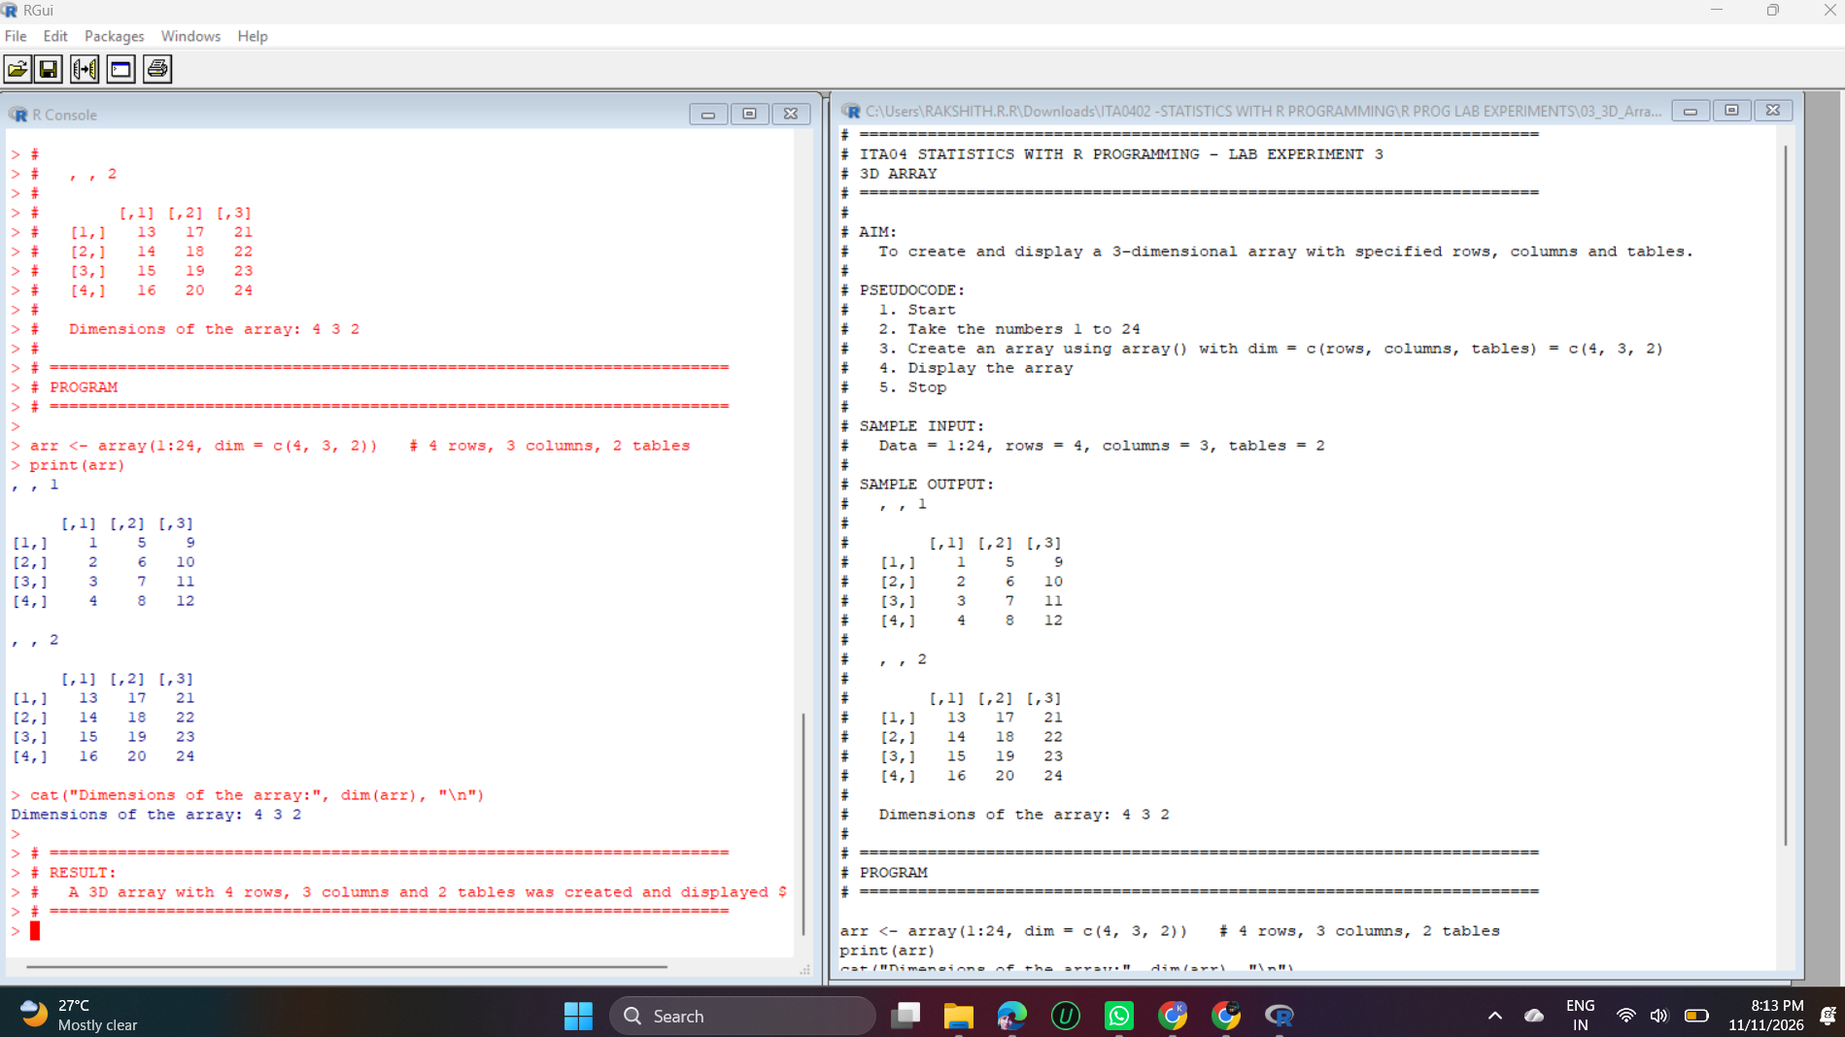
Output – Experiment 3

Explanation
array(data, dim = c(rows, columns, tables)) creates a multi-dimensional array. Here dim = c(4, 3, 2) gives 4 rows, 3 columns and 2 tables, so 4 × 3 × 2 = 24 elements are needed, which is exactly 1:24.
R fills each table column by column, so the first table holds 1–12 and the second holds 13–24. They are printed as “, , 1” and “, , 2”.
dim() returns the dimensions 4 3 2, confirming the structure.

Experiment 4: Array with Dimension Names

Question
4. Create arrays from vectors with dimension names, print specific elements.

Code
vec1 <- c(5, 9, 3)
vec2 <- c(10, 11, 12, 13, 14, 15)

result <- array(c(vec1, vec2), dim = c(3, 3, 2),
dimnames = list(c("Row1","Row2","Row3"),
c("Col1","Col2","Col3"),
c("Matrix1","Matrix2")))
print(result)

cat("\nElement at Row3, Col2 of Matrix1 :", result[3, 2, 1], "\n")
cat("Element at Row1, Col3 of Matrix2 :", result["Row1", "Col3", "Matrix2"], "\n")
print("Second matrix:")
print(result[, , 2])

Output
, , Matrix1

Col1 Col2 Col3
Row1 5 10 13
Row2 9 11 14
Row3 3 12 15

, , Matrix2

Col1 Col2 Col3
Row1 5 10 13
Row2 9 11 14
Row3 3 12 15

Element at Row3, Col2 of Matrix1 : 12
Element at Row1, Col3 of Matrix2 : 13
[1] "Second matrix:"
Col1 Col2 Col3
Row1 5 10 13
Row2 9 11 14
Row3 3 12 15

Output Screenshot
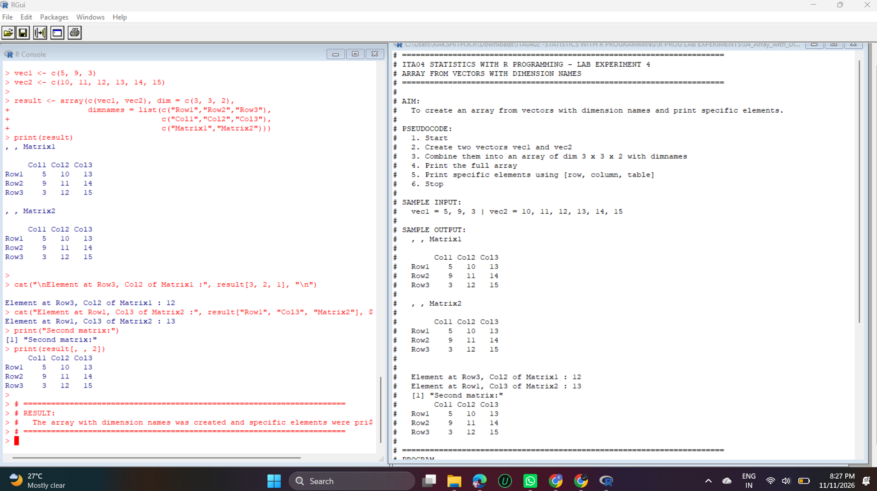
Output – Experiment 4

Explanation
c(vec1, vec2) joins the two vectors into 9 values, but a 3×3×2 array needs 18. R recycles (repeats) the 9 values, which is why Matrix2 is identical to Matrix1. This is normal R behaviour.
dimnames takes a list of three name vectors, for the rows, the columns and the matrices, so every element can be addressed by name.
Elements are accessed as [row, column, matrix]. result[3, 2, 1] gives 12, result["Row1", "Col3", "Matrix2"] gives 13 using names, and result[, , 2] prints the whole second matrix.

Experiment 5: Factor Variables

Question
5. Create and manipulate factor variables (e.g., women’s dataset heights, random LETTERS sample).

Code
# Part 1: women dataset
h <- factor(women$height)
print(levels(h))
cat("Number of levels:", nlevels(h), "\n")
print(summary(h)[1:5])

# Part 2: random sample of LETTERS
set.seed(1)
s <- sample(LETTERS, 10, replace = TRUE)
f <- factor(s)
print(s)
print(f)
print(table(f))

# Part 3: ordered factor
size <- factor(c("Low", "High", "Medium", "Low"),
levels = c("Low", "Medium", "High"), ordered = TRUE)
print(size)
print(size[2] > size[1])

Output
[1] "58" "59" "60" "61" "62" "63" "64" "65" "66" "67" "68" "69" "70" "71" "72"
Number of levels: 15
58 59 60 61 62
1 1 1 1 1
[1] "Y" "D" "G" "A" "B" "W" "K" "N" "R" "S"
[1] Y D G A B W K N R S
Levels: A B D G K N R S W Y
f
A B D G K N R S W Y
1 1 1 1 1 1 1 1 1 1
[1] Low High Medium Low
Levels: Low < Medium < High
[1] TRUE

Output Screenshot
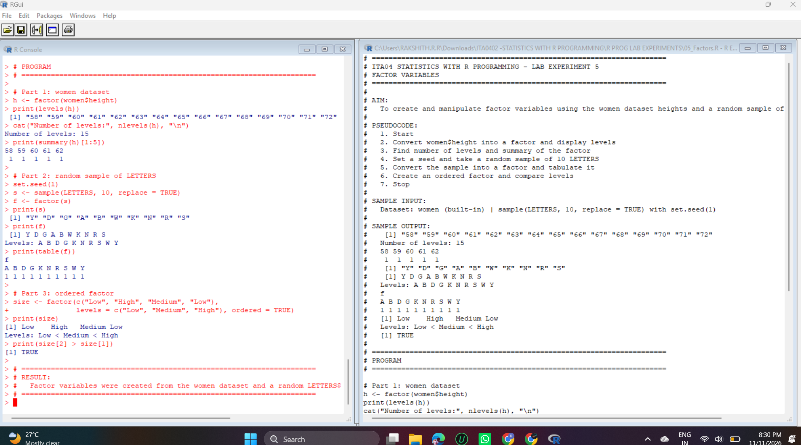
Output – Experiment 5

Explanation
factor() stores categorical data as levels. women$height has 15 different heights (58 to 72), so the factor has 15 levels and each level occurs once.
set.seed(1) makes the random result repeatable. sample(LETTERS, 10, replace = TRUE) picks 10 random capital letters, and factor() turns them into a factor whose levels are sorted alphabetically. table() counts how often each level occurs.
The ordered factor uses levels Low < Medium < High. Because the order is defined, comparisons are allowed: size[2] (High) > size[1] (Low) returns TRUE.

Experiment 6: List

Question
6. Create an R list containing vectors, matrices, and functions; display contents.

Code
my_vec <- c(1, 2, 3, 4, 5)
my_mat <- matrix(1:4, nrow = 2)
square <- function(x) {
return(x^2)
}

my_list <- list(vector = my_vec, matrix = my_mat, func = square)

print(my_list)

cat("\nVector element :", my_list$vector, "\n")
cat("Function call square(4) =", my_list$func(4), "\n")

Output
$vector
[1] 1 2 3 4 5

$matrix
[,1] [,2]
[1,] 1 3
[2,] 2 4

$func
function(x) {
return(x^2)
}

Vector element : 1 2 3 4 5
Function call square(4) = 16

Output Screenshot
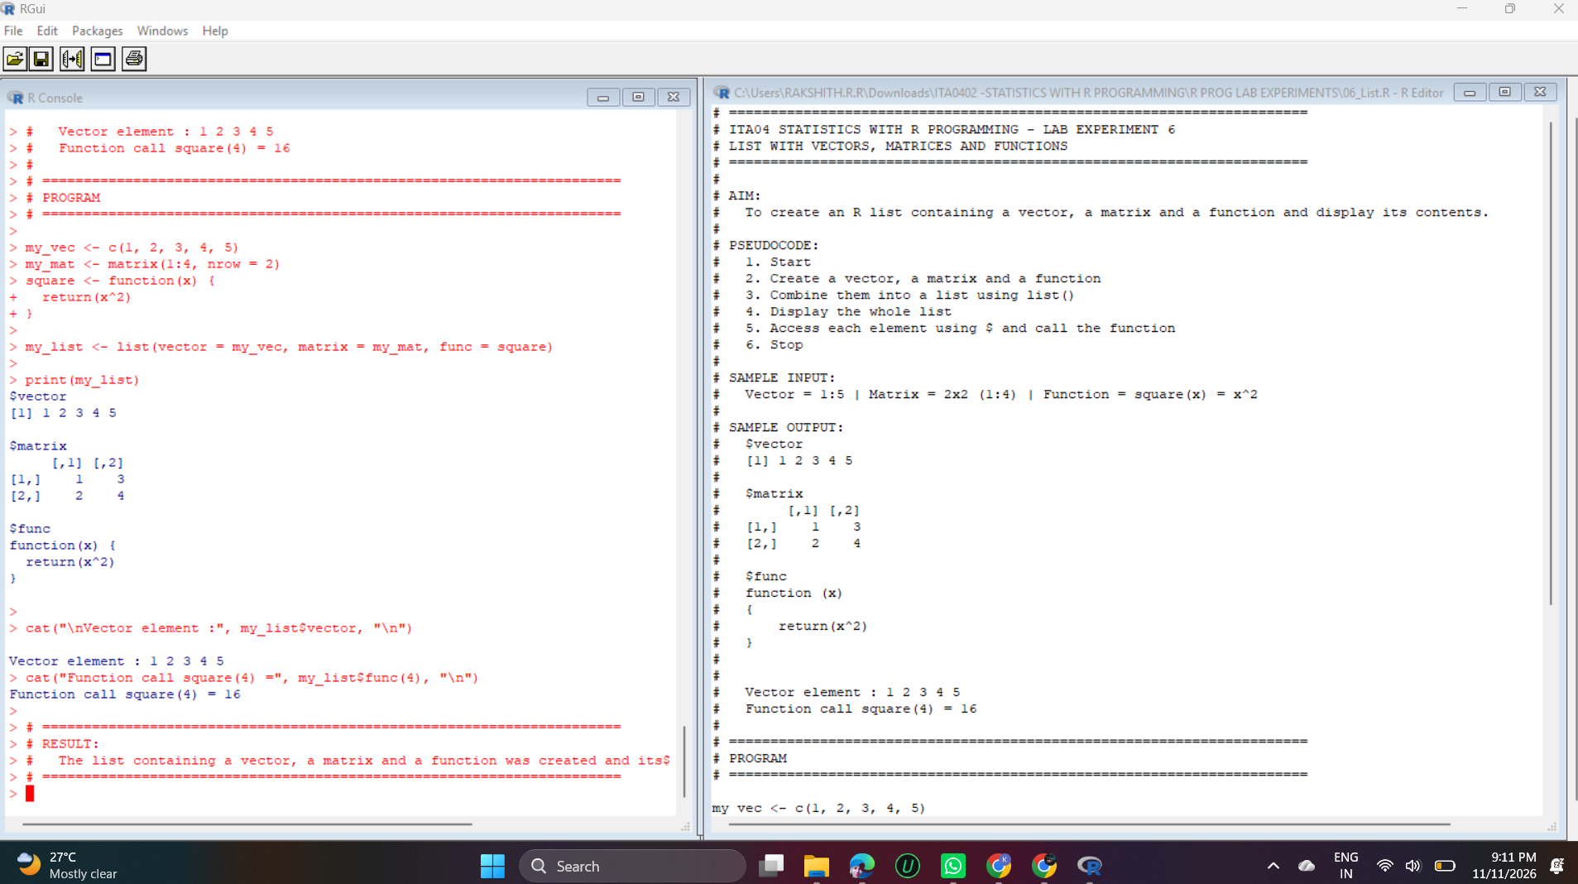
Output – Experiment 6

Explanation
A list can store elements of different types in one object. Here it holds a numeric vector, a 2×2 matrix and a function.
Elements are accessed by name with $. my_list$vector gives the vector and my_list$func(4) calls the stored function, returning 4² = 16.
print(my_list) displays all three components, including the source code of the function.

Experiment 7: Factors, Random Integers and FizzBuzz

Question
7. Write R programs for basic tasks: Factors of a number, generate a vector of 10 random integers between -50 and 50, print numbers 1–100 with FizzBuzz logic.

Code
# (a) Factors of a number
n <- 24
cat("Factors of", n, "are: ")
for (i in 1:n) {
if (n %% i == 0) cat(i, "")
}
cat("\n\n")

# (b) 10 random integers between -50 and 50
set.seed(10)
rand_vec <- sample(-50:50, 10, replace = TRUE)
cat("Random integers:", rand_vec, "\n\n")

# (c) FizzBuzz 1 to 100
for (i in 1:100) {
if (i %% 15 == 0) {
print("FizzBuzz")
} else if (i %% 3 == 0) {
print("Fizz")
} else if (i %% 5 == 0) {
print("Buzz")
} else {
print(i)
}
}

Output
Factors of 24 are: 1 2 3 4 6 8 12 24

Random integers: -42 23 25 4 21 3 -12 32 37 -36

[1] 1
[1] 2
[1] "Fizz"
[1] 4
[1] "Buzz"
[1] "Fizz"
[1] 7
[1] 8
[1] "Fizz"
[1] "Buzz"
[1] 11
[1] "Fizz"
[1] 13
[1] 14
[1] "FizzBuzz"
[1] 16
[1] 17
[1] "Fizz"
[1] 19
[1] "Buzz"
[1] "Fizz"
[1] 22
[1] 23
[1] "Fizz"
[1] "Buzz"
[1] 26
[1] "Fizz"
[1] 28
[1] 29
[1] "FizzBuzz"
[1] 31
[1] 32
[1] "Fizz"
[1] 34
[1] "Buzz"
[1] "Fizz"
[1] 37
[1] 38
[1] "Fizz"
[1] "Buzz"
[1] 41
[1] "Fizz"
[1] 43
[1] 44
[1] "FizzBuzz"
[1] 46
[1] 47
[1] "Fizz"
[1] 49
[1] "Buzz"
[1] "Fizz"
[1] 52
[1] 53
[1] "Fizz"
[1] "Buzz"
[1] 56
[1] "Fizz"
[1] 58
[1] 59
[1] "FizzBuzz"
[1] 61
[1] 62
[1] "Fizz"
[1] 64
[1] "Buzz"
[1] "Fizz"
[1] 67
[1] 68
[1] "Fizz"
[1] "Buzz"
[1] 71
[1] "Fizz"
[1] 73
[1] 74
[1] "FizzBuzz"
[1] 76
[1] 77
[1] "Fizz"
[1] 79
[1] "Buzz"
[1] "Fizz"
[1] 82
[1] 83
[1] "Fizz"
[1] "Buzz"
[1] 86
[1] "Fizz"
[1] 88
[1] 89
[1] "FizzBuzz"
[1] 91
[1] 92
[1] "Fizz"
[1] 94
[1] "Buzz"
[1] "Fizz"
[1] 97
[1] 98
[1] "Fizz"
[1] "Buzz"

Output Screenshot
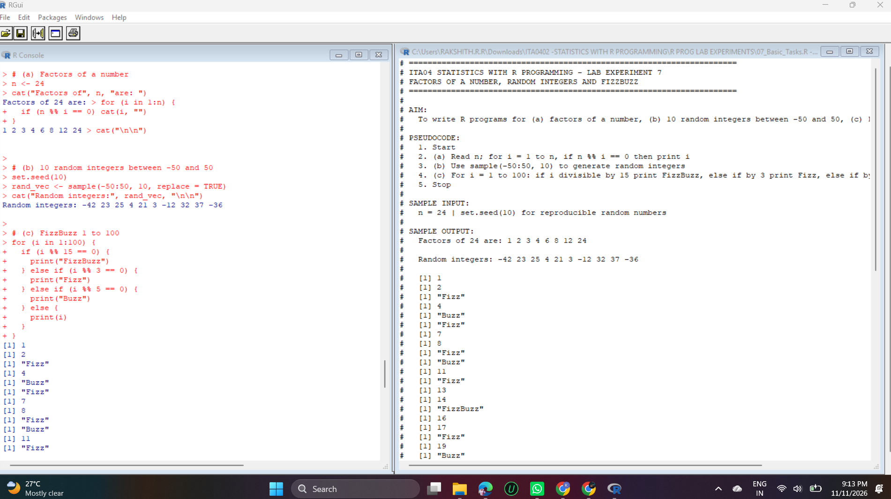
Output – Experiment 7

Explanation
(a) The for loop checks every number from 1 to n and prints those where n %% i == 0 (remainder zero). The factors of 24 are 1, 2, 3, 4, 6, 8, 12 and 24.
(b) sample(-50:50, 10, replace = TRUE) picks 10 random integers from -50 to 50. set.seed(10) makes the same numbers appear every time.
(c) FizzBuzz prints “FizzBuzz” for multiples of 15, “Fizz” for multiples of 3, “Buzz” for multiples of 5 and the number itself otherwise. The multiple-of-15 test must come first, otherwise those numbers would only print “Fizz”.

Experiment 8: Normal Distribution

Question
8. Generate random numbers from a normal distribution; count occurrences.

Code
set.seed(123)
x <- rnorm(20, mean = 5, sd = 2)
print(round(x, 2))

r <- round(x)
cat("\nRounded values:", r, "\n")

cat("\nOccurrences of each value:\n")
print(table(r))

cat("\nNumbers greater than the mean (", round(mean(x), 2), "):", sum(x > mean(x)), "\n")

Output
[1] 3.88 4.54 8.12 5.14 5.26 8.43 5.92 2.47 3.63 4.11 7.45 5.72 5.80 5.22 3.89
[16] 8.57 6.00 1.07 6.40 4.05

Rounded values: 4 5 8 5 5 8 6 2 4 4 7 6 6 5 4 9 6 1 6 4

Occurrences of each value:
r
1 2 4 5 6 7 8 9
1 1 5 4 5 1 2 1

Numbers greater than the mean ( 5.28 ): 9

Output Screenshot
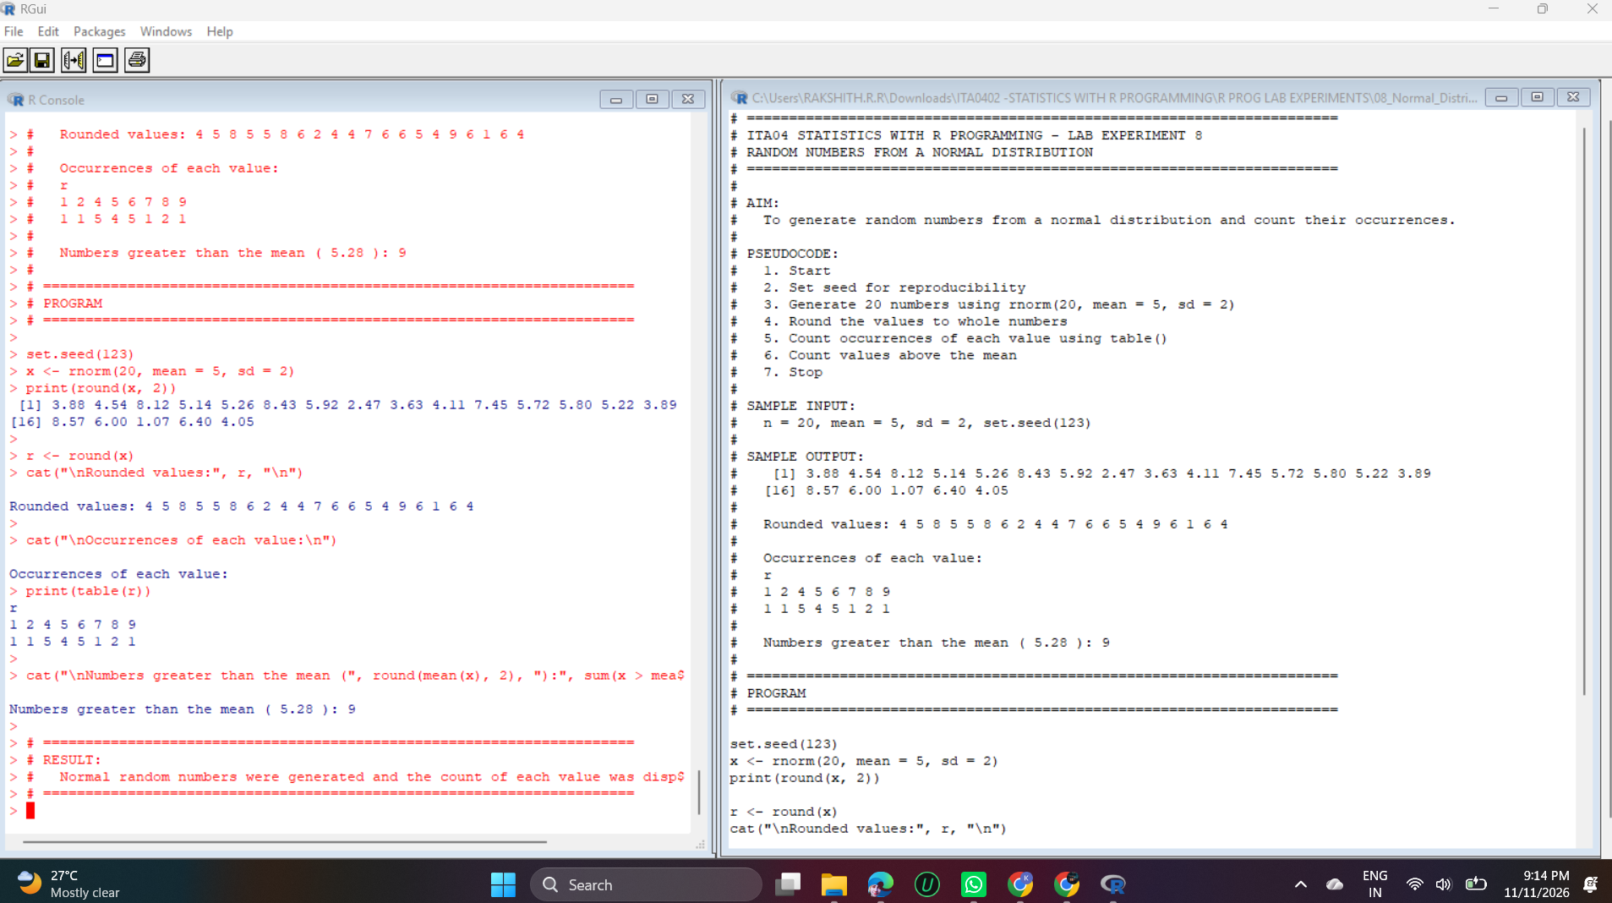
Output – Experiment 8

Explanation
rnorm(20, mean = 5, sd = 2) generates 20 random values from a normal distribution centred around 5 with a spread of 2. set.seed(123) fixes the random numbers so the output is repeatable.
round() converts the values to whole numbers and table() counts the occurrences of each. The values 4 and 6 occur five times each, 5 occurs four times, and 1, 2, 7 and 9 occur once each.
The mean of the generated data is 5.28, and sum(x > mean(x)) counts the 9 values that are greater than the mean.

Experiment 9: Empty Plots

Question
9. Create empty plots with specified axis limits.

Code
par(mfrow = c(1, 2)) # two plots side by side

plot(1, type = "n", xlim = c(0, 10), ylim = c(0, 50),
xlab = "X axis", ylab = "Y axis", main = "Empty plot 1")

plot(1, type = "n", xlim = c(-5, 5), ylim = c(-10, 10),
xlab = "X axis", ylab = "Y axis", main = "Empty plot 2")

par(mfrow = c(1, 1))
cat("Two empty plots created.\n")

Output
Two empty plots created.

Output Screenshot
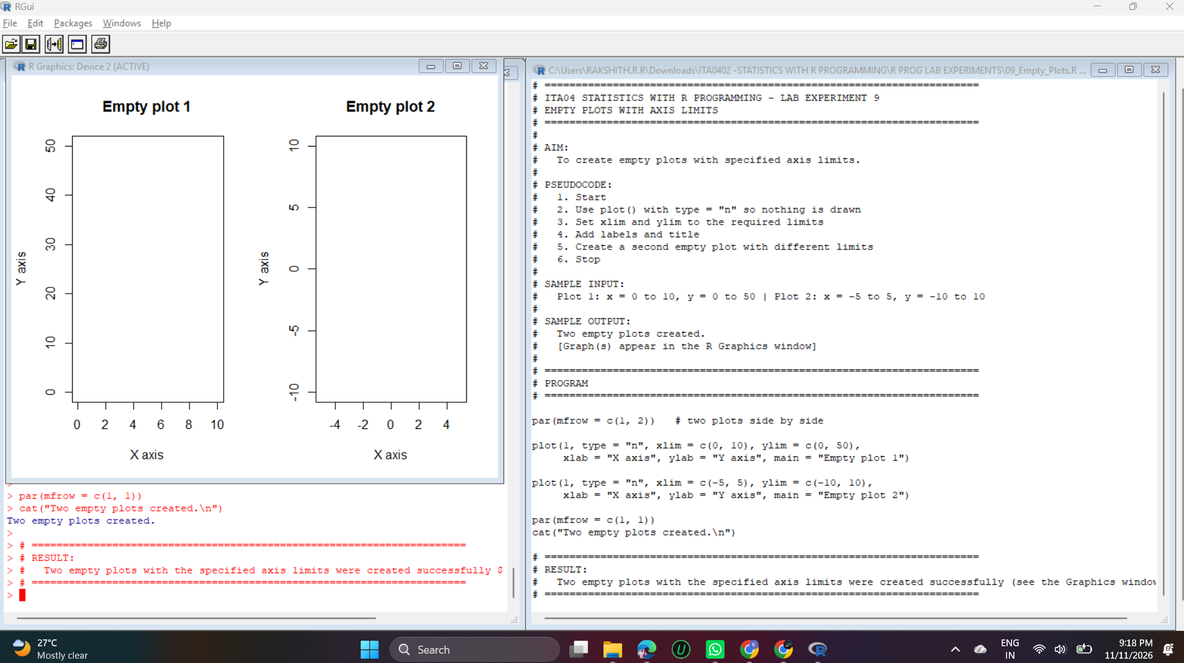
Output – Experiment 9

Explanation
plot(1, type = "n") draws only the axes and the frame without any points or lines, creating an empty plot.
xlim and ylim set the axis ranges (0–10 and 0–50 for plot 1, -5 to 5 and -10 to 10 for plot 2), and xlab, ylab and main add the labels and title.
par(mfrow = c(1, 2)) arranges two plots side by side. Such empty plots are used as a blank canvas to which points or lines are added later.

Experiment 10: Data Frame exam_data

Question
10. Create and explore a data frame exam_data with name, score, attempts, and qualify fields. Perform extract, add row/column, sort, save to file.

Code
exam_data <- data.frame(
name = c("Anastasia", "Dima", "Katherine", "James", "Emily",
"Michael", "Matthew", "Laura", "Kevin", "Jonas"),
score = c(12.5, 9, 16.5, NA, 9, 20, 14.5, 13.5, 8, 19),
attempts = c(1, 3, 2, 3, 2, 3, 1, 1, 2, 1),
qualify = c("yes", "no", "yes", "no", "no", "yes", "yes", "no", "no", "yes"),
stringsAsFactors = FALSE
)

print(exam_data)
str(exam_data)

# Extract
cat("\nFirst two rows:\n"); print(exam_data[1:2, ])
cat("\nName and score columns:\n"); print(exam_data[, c("name", "score")])

# Add a new row
new_row <- data.frame(name = "Suresh", score = 15, attempts = 1, qualify = "yes")
exam_data <- rbind(exam_data, new_row)

# Add a new column
exam_data$country <- "India"
cat("\nAfter adding row and column:\n"); print(exam_data)

# Sort by score (descending)
sorted_data <- exam_data[order(-exam_data$score), ]
cat("\nSorted by score:\n"); print(sorted_data)

# Save to file
write.csv(exam_data, "exam_data.csv", row.names = FALSE)
cat("\nFile exam_data.csv saved in:", getwd(), "\n")

Output
name score attempts qualify
1 Anastasia 12.5 1 yes
2 Dima 9.0 3 no
3 Katherine 16.5 2 yes
4 James NA 3 no
5 Emily 9.0 2 no
6 Michael 20.0 3 yes
7 Matthew 14.5 1 yes
8 Laura 13.5 1 no
9 Kevin 8.0 2 no
10 Jonas 19.0 1 yes
'data.frame': 10 obs. of 4 variables:
$ name : chr "Anastasia" "Dima" "Katherine" "James" ...
$ score : num 12.5 9 16.5 NA 9 20 14.5 13.5 8 19
$ attempts: num 1 3 2 3 2 3 1 1 2 1
$ qualify : chr "yes" "no" "yes" "no" ...

First two rows:
name score attempts qualify
1 Anastasia 12.5 1 yes
2 Dima 9.0 3 no

Name and score columns:
name score
1 Anastasia 12.5
2 Dima 9.0
3 Katherine 16.5
4 James NA
5 Emily 9.0
6 Michael 20.0
7 Matthew 14.5
8 Laura 13.5
9 Kevin 8.0
10 Jonas 19.0

After adding row and column:
name score attempts qualify country
1 Anastasia 12.5 1 yes India
2 Dima 9.0 3 no India
3 Katherine 16.5 2 yes India
4 James NA 3 no India
5 Emily 9.0 2 no India
6 Michael 20.0 3 yes India
7 Matthew 14.5 1 yes India
8 Laura 13.5 1 no India
9 Kevin 8.0 2 no India
10 Jonas 19.0 1 yes India
11 Suresh 15.0 1 yes India

Sorted by score:
name score attempts qualify country
6 Michael 20.0 3 yes India
10 Jonas 19.0 1 yes India
3 Katherine 16.5 2 yes India
11 Suresh 15.0 1 yes India
7 Matthew 14.5 1 yes India
8 Laura 13.5 1 no India
1 Anastasia 12.5 1 yes India
2 Dima 9.0 3 no India
5 Emily 9.0 2 no India
9 Kevin 8.0 2 no India
4 James NA 3 no India

File exam_data.csv saved in: C:/Users/RAKSHITH.R.R/OneDrive/文档

Output Screenshot
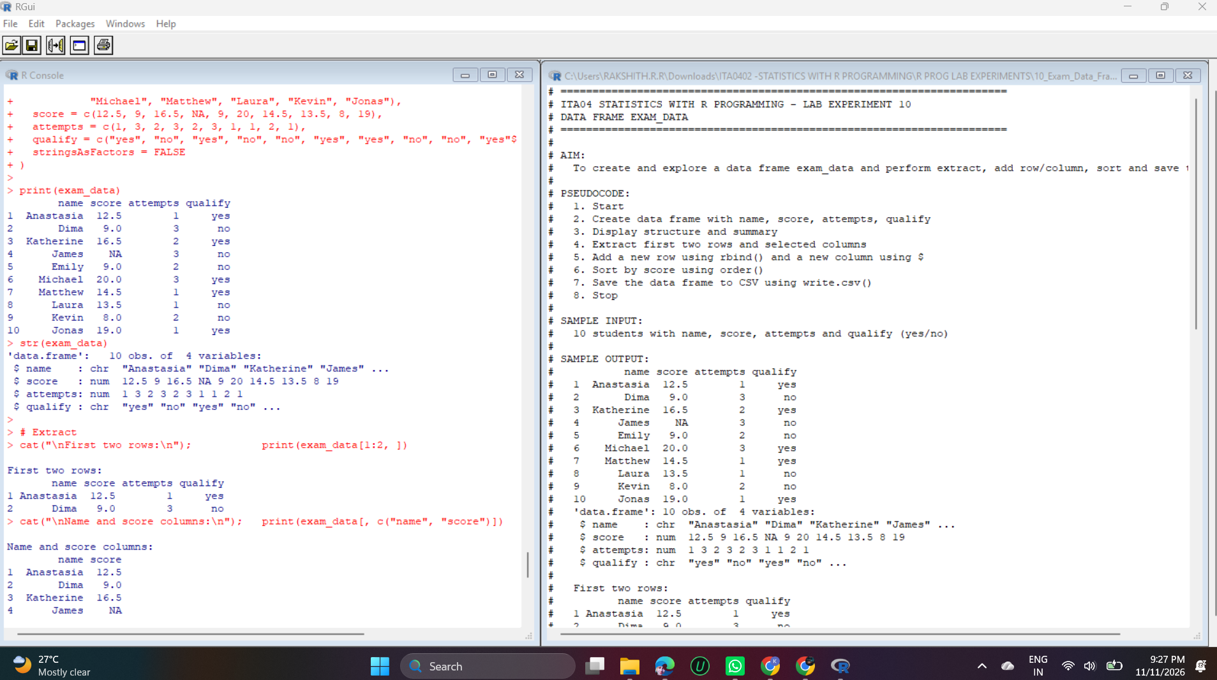
Output – Experiment 10

Explanation
data.frame() creates a table with the columns name, score, attempts and qualify, and str() shows its structure.
Extract: exam_data[1:2, ] selects the first two rows and exam_data[, c("name", "score")] selects two columns.
Add: rbind() appends a new row (Suresh) and exam_data$country <- "India" adds a new column.
Sort: order(-exam_data$score) sorts by score in descending order, and the NA value (James) is placed last.
Save: write.csv() writes the data frame to exam_data.csv in the working directory, and getwd() prints that location.

Experiment 11: Read a CSV File

Question
11. Write an R program to read a .csv file and display contents.

Code
# Create a sample CSV file
students <- data.frame(id = 1:5,
name = c("Arun", "Bala", "Charan", "Divya", "Esha"),
marks = c(85, 72, 90, 66, 78))
write.csv(students, "students.csv", row.names = FALSE)

# Read the CSV file
data <- read.csv("students.csv")

print(data)
str(data)
cat("Rows:", nrow(data), " Columns:", ncol(data), "\n")

Output
id name marks
1 1 Arun 85
2 2 Bala 72
3 3 Charan 90
4 4 Divya 66
5 5 Esha 78
'data.frame': 5 obs. of 3 variables:
$ id : int 1 2 3 4 5
$ name : chr "Arun" "Bala" "Charan" "Divya" ...
$ marks: int 85 72 90 66 78
Rows: 5 Columns: 3

Output Screenshot
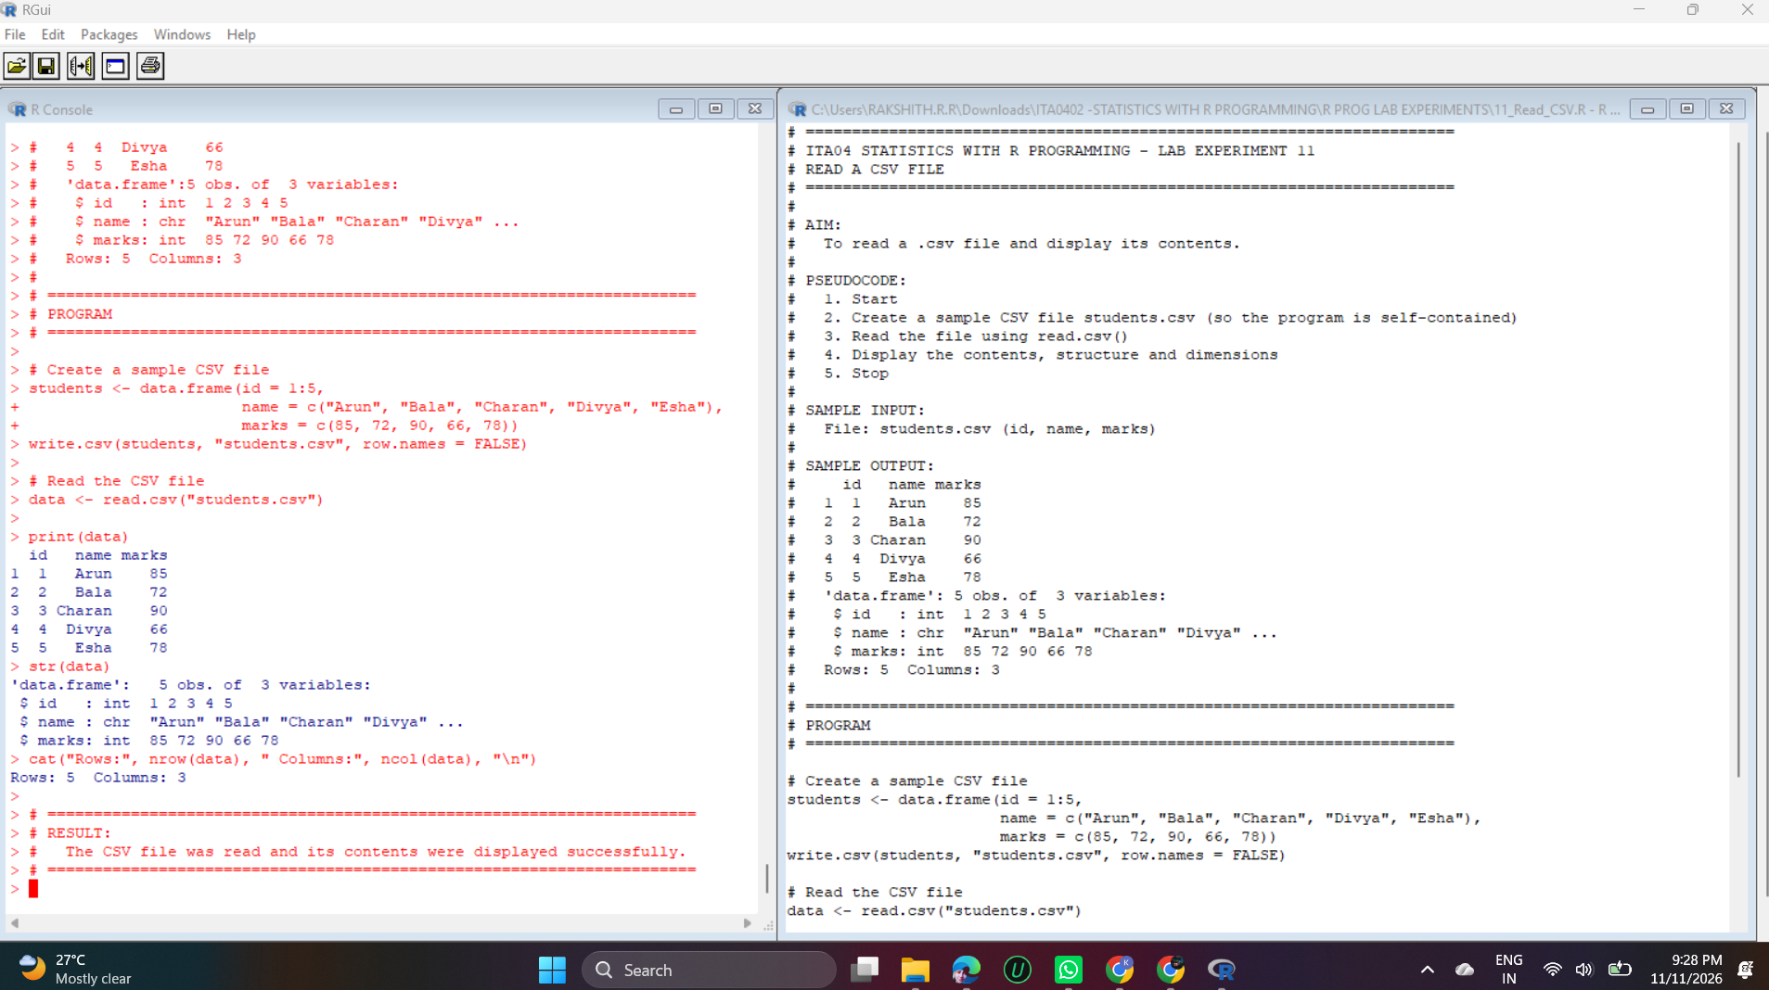
Output – Experiment 11

Explanation
write.csv() first creates a sample file, students.csv, so the program is self-contained.
read.csv() reads the file back into a data frame, and print() displays its contents. str() shows that id and marks are integers and name is text. nrow() and ncol() report 5 rows and 3 columns.

Experiment 12: Airquality Reshaping

Question
12. Perform data reshaping on airquality dataset: melt, cast, compute monthly averages for Ozone, Solar.R, Wind, and Temperature.

Code
if (!require(reshape2)) install.packages("reshape2")
library(reshape2)

names(airquality) <- tolower(names(airquality))
print(head(airquality))

# MELT: wide to long
aq_melt <- melt(airquality, id.vars = c("month", "day"), na.rm = TRUE)
cat("\nMolten data:\n")
print(head(aq_melt))

# CAST: long to wide with monthly averages
monthly_avg <- dcast(aq_melt, month ~ variable, mean)
cat("\nMonthly averages:\n")
print(round(monthly_avg, 2))

Output
ozone solar.r wind temp month day
1 41 190 7.4 67 5 1
2 36 118 8.0 72 5 2
3 12 149 12.6 74 5 3
4 18 313 11.5 62 5 4
5 NA NA 14.3 56 5 5
6 28 NA 14.9 66 5 6

Molten data:
month day variable value
1 5 1 ozone 41
2 5 2 ozone 36
3 5 3 ozone 12
4 5 4 ozone 18
6 5 6 ozone 28
7 5 7 ozone 23

Monthly averages:
month ozone solar.r wind temp
1 5 23.62 181.30 11.62 65.55
2 6 29.44 190.17 10.27 79.10
3 7 59.12 216.48 8.94 83.90
4 8 59.96 171.86 8.79 83.97
5 9 31.45 167.43 10.18 76.90

Output Screenshot
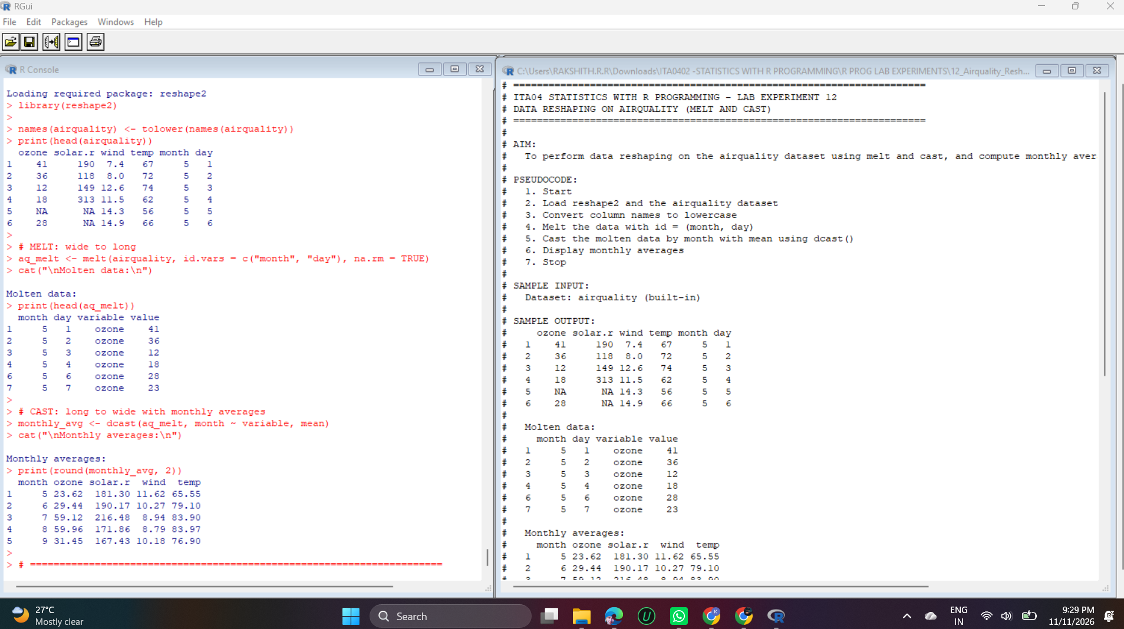
Output – Experiment 12

Explanation
The column names are changed to lowercase with tolower(). melt() from the reshape2 package converts the data from wide to long format: month and day stay as identifiers, and ozone, solar.r, wind and temp become variable/value pairs. na.rm = TRUE removes missing values, which is why row 5 of the original data is missing in the molten output.
dcast(aq_melt, month ~ variable, mean) casts the long data back to wide format with one row per month and the mean of each variable.
The monthly averages show that ozone and temperature are highest in July and August (ozone about 59, temperature about 84) and lowest in May.

Experiment 13: Combine Arrays Row-wise

Question
13. Combine multiple arrays row-wise.

Code
arr1 <- array(1:6, dim = c(2, 3))
arr2 <- array(7:12, dim = c(2, 3))
arr3 <- array(13:18, dim = c(2, 3))

combined <- rbind(arr1, arr2, arr3)

print("Combined row-wise:")
print(combined)
cat("Dimensions:", dim(combined), "\n")

Output
[1] "Combined row-wise:"
[,1] [,2] [,3]
[1,] 1 3 5
[2,] 2 4 6
[3,] 7 9 11
[4,] 8 10 12
[5,] 13 15 17
[6,] 14 16 18
Dimensions: 6 3

Output Screenshot
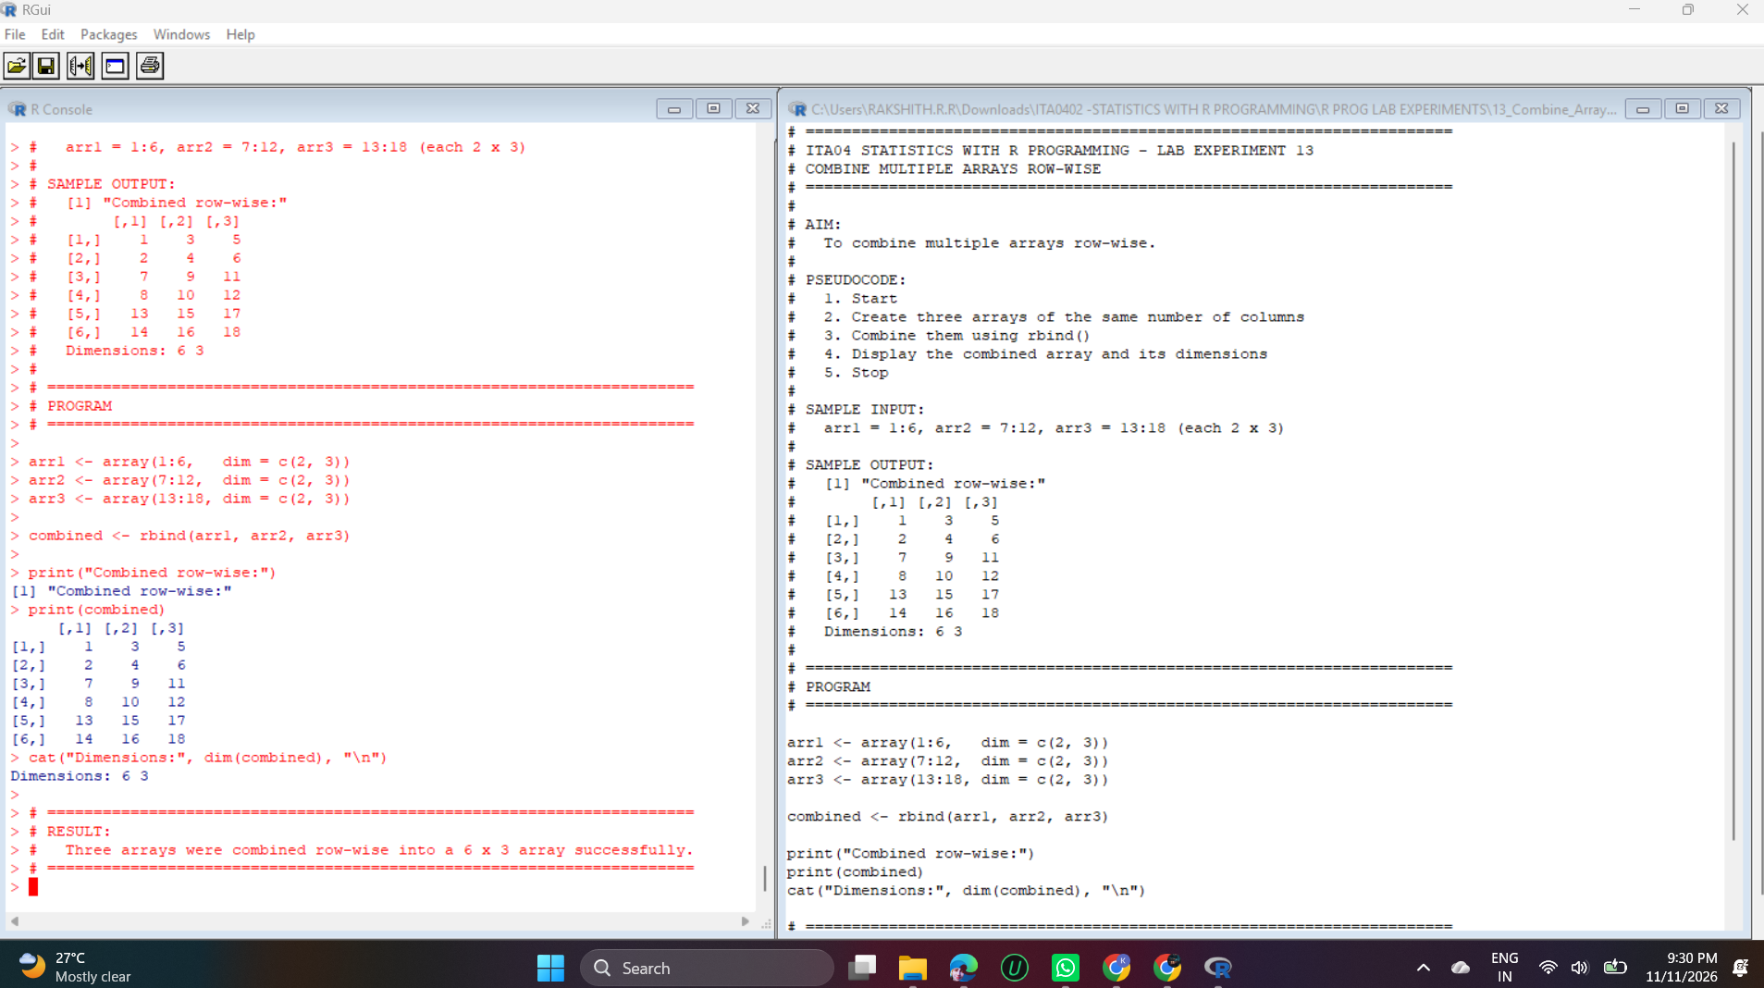
Output – Experiment 13

Explanation
array(..., dim = c(2, 3)) creates three arrays of 2 rows and 3 columns.
rbind() joins them one below the other (row-wise), giving 2 + 2 + 2 = 6 rows and 3 columns. Row-wise combining requires the same number of columns in every array.
dim() confirms the combined result is 6 × 3.

Experiment 14: ChickWeight Dataset

Question
14. Explore and manipulate ChickWeight dataset (sorting, melting, casting by Diet).

Code
library(reshape2)

cw <- as.data.frame(ChickWeight)
print(head(cw))
str(cw)

# Sorting (heaviest first)
cat("\nTop 5 heaviest records:\n")
print(head(cw[order(-cw$weight), ], 5))

# Melting
cw_melt <- melt(cw, id.vars = c("Chick", "Diet", "Time"), measure.vars = "weight")
cat("\nMolten data:\n")
print(head(cw_melt))

# Casting by Diet
cat("\nAverage weight by Diet:\n")
print(dcast(cw_melt, Diet ~ variable, mean))

# Casting by Diet and Time
cat("\nAverage weight by Diet at Time 0, 10, 20:\n")
sub <- cw_melt[cw_melt$Time %in% c(0, 10, 20), ]
tbl <- dcast(sub, Diet ~ Time, mean)
tbl[, -1] <- round(tbl[, -1], 2)
print(tbl)

Output
weight Time Chick Diet
1 42 0 1 1
2 51 2 1 1
3 59 4 1 1
4 64 6 1 1
5 76 8 1 1
6 93 10 1 1
'data.frame': 578 obs. of 4 variables:
$ weight: num 42 51 59 64 76 93 106 125 149 171 ...
$ Time : num 0 2 4 6 8 10 12 14 16 18 ...
$ Chick : Ord.factor w/ 50 levels "18"<"16"<"15"<..: 15 15 15 15 15 15 15 15 15 15 ...
$ Diet : Factor w/ 4 levels "1","2","3","4": 1 1 1 1 1 1 1 1 1 1 ...
- attr(*, "formula")=Class 'formula' language weight ~ Time | Chick
.. ..- attr(*, ".Environment")=<environment: R_EmptyEnv>
- attr(*, "outer")=Class 'formula' language ~Diet
.. ..- attr(*, ".Environment")=<environment: R_EmptyEnv>
- attr(*, "labels")=List of 2
..$ x: chr "Time"
..$ y: chr "Body weight"
- attr(*, "units")=List of 2
..$ x: chr "(days)"
..$ y: chr "(gm)"

Top 5 heaviest records:
weight Time Chick Diet
400 373 21 35 3
399 361 20 35 3
388 341 21 34 3
398 332 18 35 3
232 331 21 21 2

Molten data:
Chick Diet Time variable value
1 1 1 0 weight 42
2 1 1 2 weight 51
3 1 1 4 weight 59
4 1 1 6 weight 64
5 1 1 8 weight 76
6 1 1 10 weight 93

Average weight by Diet:
Diet weight
1 1 102.6455
2 2 122.6167
3 3 142.9500
4 4 135.2627

Average weight by Diet at Time 0, 10, 20:
Diet 0 10 20
1 1 41.4 93.05 170.41
2 2 40.7 108.50 205.60
3 3 40.8 117.10 258.90
4 4 41.0 126.00 233.89

Output Screenshot
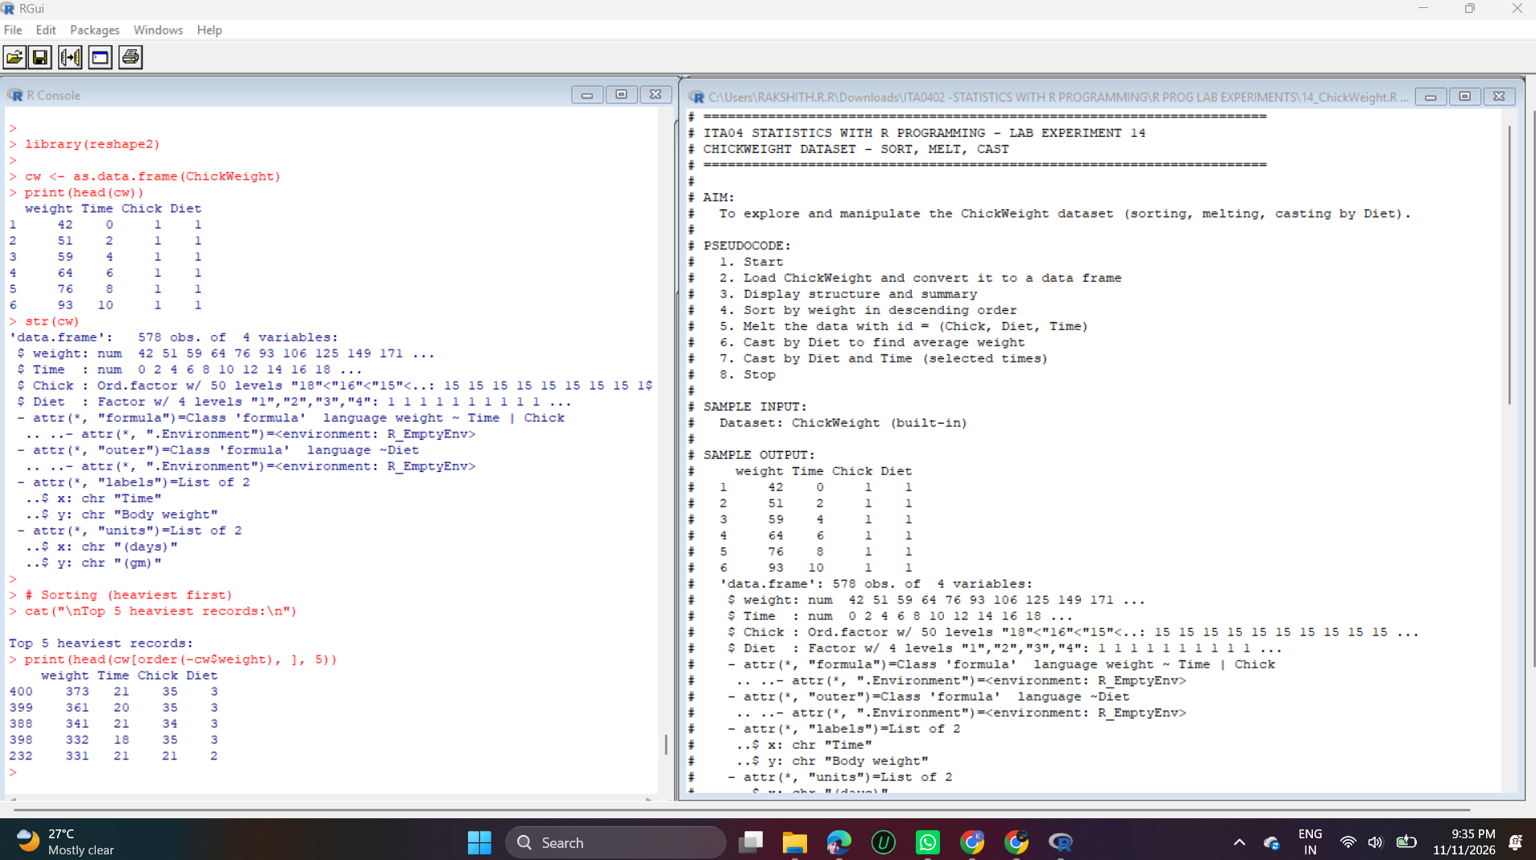
Output – Experiment 14

Explanation
ChickWeight is a built-in grouped dataset (578 observations of weight, Time, Chick and Diet), converted to a plain data frame with as.data.frame().
Sorting: order(-cw$weight) lists the heaviest records first. The heaviest chick was Chick 35 on Diet 3 with 373 g at day 21.
Melting: melt() with id.vars = c("Chick", "Diet", "Time") and measure.vars = "weight" gives the long format with variable and value columns.
Casting: dcast(Diet ~ variable, mean) gives the average weight per diet. Diet 3 is the highest (142.95) and Diet 1 the lowest (102.65). The Diet × Time table shows that all diets start at about 41 g, and by day 20 Diet 3 is heaviest (258.9 g).

Experiment 15: EDA on iris

Question
15. Perform EDA on iris dataset: dimensions, summary, standard deviation, quantiles, grouping by Species, pivot table, categorical grouping with Sepal.Length categories.

Code
data(iris)
cat("Dimensions:", dim(iris), "\n\n")
print(head(iris))

cat("\nSummary:\n")
print(summary(iris))

cat("\nStandard deviation:\n")
print(sapply(iris[, 1:4], sd))

cat("\nQuantiles of Sepal.Length:\n")
print(quantile(iris$Sepal.Length))

cat("\nMean of each variable grouped by Species:\n")
print(aggregate(. ~ Species, data = iris, FUN = mean))

cat("\nPivot table (mean Petal.Length by Species):\n")
print(tapply(iris$Petal.Length, iris$Species, mean))

cat("\nSepal.Length categories:\n")
iris$SL_cat <- cut(iris$Sepal.Length, breaks = c(0, 5.5, 6.5, 10),
labels = c("Short", "Medium", "Long"))
print(table(iris$Species, iris$SL_cat))

Output
Dimensions: 150 5

Sepal.Length Sepal.Width Petal.Length Petal.Width Species
1 5.1 3.5 1.4 0.2 setosa
2 4.9 3.0 1.4 0.2 setosa
3 4.7 3.2 1.3 0.2 setosa
4 4.6 3.1 1.5 0.2 setosa
5 5.0 3.6 1.4 0.2 setosa
6 5.4 3.9 1.7 0.4 setosa

Summary:
Sepal.Length Sepal.Width Petal.Length Petal.Width
Min. :4.300 Min. :2.000 Min. :1.000 Min. :0.100
1st Qu.:5.100 1st Qu.:2.800 1st Qu.:1.600 1st Qu.:0.300
Median :5.800 Median :3.000 Median :4.350 Median :1.300
Mean :5.843 Mean :3.057 Mean :3.758 Mean :1.199
3rd Qu.:6.400 3rd Qu.:3.300 3rd Qu.:5.100 3rd Qu.:1.800
Max. :7.900 Max. :4.400 Max. :6.900 Max. :2.500
Species
setosa :50
versicolor:50
virginica :50

Standard deviation:
Sepal.Length Sepal.Width Petal.Length Petal.Width
0.8280661 0.4358663 1.7652982 0.7622377

Quantiles of Sepal.Length:
0% 25% 50% 75% 100%
4.3 5.1 5.8 6.4 7.9

Mean of each variable grouped by Species:
Species Sepal.Length Sepal.Width Petal.Length Petal.Width
1 setosa 5.006 3.428 1.462 0.246
2 versicolor 5.936 2.770 4.260 1.326
3 virginica 6.588 2.974 5.552 2.026

Pivot table (mean Petal.Length by Species):
setosa versicolor virginica
1.462 4.260 5.552

Sepal.Length categories:

Short Medium Long
setosa 47 3 0
versicolor 11 31 8
virginica 1 27 22

Output Screenshot
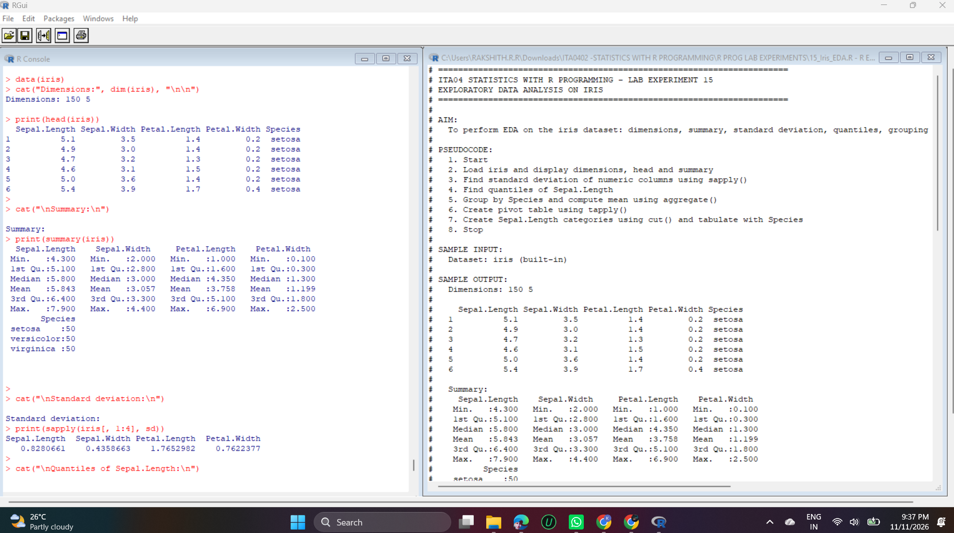
Output – Experiment 15

Explanation
dim() shows the dataset has 150 rows and 5 columns, head() shows the first six rows and summary() gives the min, quartiles, mean and max of each column plus the count per species.
sapply(iris[, 1:4], sd) gives the standard deviation of each numeric column. Petal.Length has the largest spread (1.77), so it varies the most. quantile() shows the 0%, 25%, 50%, 75% and 100% points of Sepal.Length.
aggregate(. ~ Species, FUN = mean) gives the mean of each variable per species (setosa has the smallest petals), and tapply() gives the same kind of pivot table for Petal.Length.
cut() converts Sepal.Length into the categories Short (up to 5.5), Medium (5.5–6.5) and Long (above 6.5). The cross-table shows that setosa is mostly Short, versicolor mostly Medium and virginica Medium or Long.

Experiment 16: USArrests Dataset

Question
16. Explore USArrests dataset: summary statistics, state with largest rape arrests, max & min murder rates, correlation among features, states above median assault arrests and bottom 25% for murder, visualization with histogram, density, scatterplots, bar graphs.

Code
data(USArrests)
print(head(USArrests))
cat("\nSummary:\n"); print(summary(USArrests))

cat("\nState with largest Rape arrests:", rownames(USArrests)[which.max(USArrests$Rape)], "\n")
cat("State with maximum Murder rate :", rownames(USArrests)[which.max(USArrests$Murder)],
"(", max(USArrests$Murder), ")\n")
cat("State with minimum Murder rate :", rownames(USArrests)[which.min(USArrests$Murder)],
"(", min(USArrests$Murder), ")\n")

cat("\nCorrelation among features:\n")
print(round(cor(USArrests), 2))

cat("\nStates with Assault above median:\n")
print(rownames(USArrests)[USArrests$Assault > median(USArrests$Assault)])

cat("\nStates in bottom 25% for Murder:\n")
print(rownames(USArrests)[USArrests$Murder <= quantile(USArrests$Murder, 0.25)])

# Visualization
par(mfrow = c(2, 2))
hist(USArrests$Murder, main = "Histogram of Murder", xlab = "Murder", col = "skyblue")
plot(density(USArrests$Assault), main = "Density of Assault", col = "red")
plot(USArrests$Assault, USArrests$Murder, main = "Assault vs Murder",
xlab = "Assault", ylab = "Murder", pch = 19, col = "blue")
barplot(head(USArrests$Murder, 10), names.arg = head(rownames(USArrests), 10),
las = 2, main = "Murder rate (first 10 states)", col = "orange")
par(mfrow = c(1, 1))

Output
Murder Assault UrbanPop Rape
Alabama 13.2 236 58 21.2
Alaska 10.0 263 48 44.5
Arizona 8.1 294 80 31.0
Arkansas 8.8 190 50 19.5
California 9.0 276 91 40.6
Colorado 7.9 204 78 38.7

Summary:
Murder Assault UrbanPop Rape
Min. : 0.800 Min. : 45.0 Min. :32.00 Min. : 7.30
1st Qu.: 4.075 1st Qu.:109.0 1st Qu.:54.50 1st Qu.:15.07
Median : 7.250 Median :159.0 Median :66.00 Median :20.10
Mean : 7.788 Mean :170.8 Mean :65.54 Mean :21.23
3rd Qu.:11.250 3rd Qu.:249.0 3rd Qu.:77.75 3rd Qu.:26.18
Max. :17.400 Max. :337.0 Max. :91.00 Max. :46.00

State with largest Rape arrests: Nevada
State with maximum Murder rate : Georgia ( 17.4 )
State with minimum Murder rate : North Dakota ( 0.8 )

Correlation among features:
Murder Assault UrbanPop Rape
Murder 1.00 0.80 0.07 0.56
Assault 0.80 1.00 0.26 0.67
UrbanPop 0.07 0.26 1.00 0.41
Rape 0.56 0.67 0.41 1.00

States with Assault above median:
[1] "Alabama" "Alaska" "Arizona" "Arkansas"
[5] "California" "Colorado" "Delaware" "Florida"
[9] "Georgia" "Illinois" "Louisiana" "Maryland"
[13] "Michigan" "Mississippi" "Missouri" "Nevada"
[17] "New Mexico" "New York" "North Carolina" "Rhode Island"
[21] "South Carolina" "Tennessee" "Texas" "Wyoming"

States in bottom 25% for Murder:
[1] "Connecticut" "Idaho" "Iowa" "Maine"
[5] "Minnesota" "New Hampshire" "North Dakota" "Rhode Island"
[9] "South Dakota" "Utah" "Vermont" "Washington"
[13] "Wisconsin"

Output Screenshots
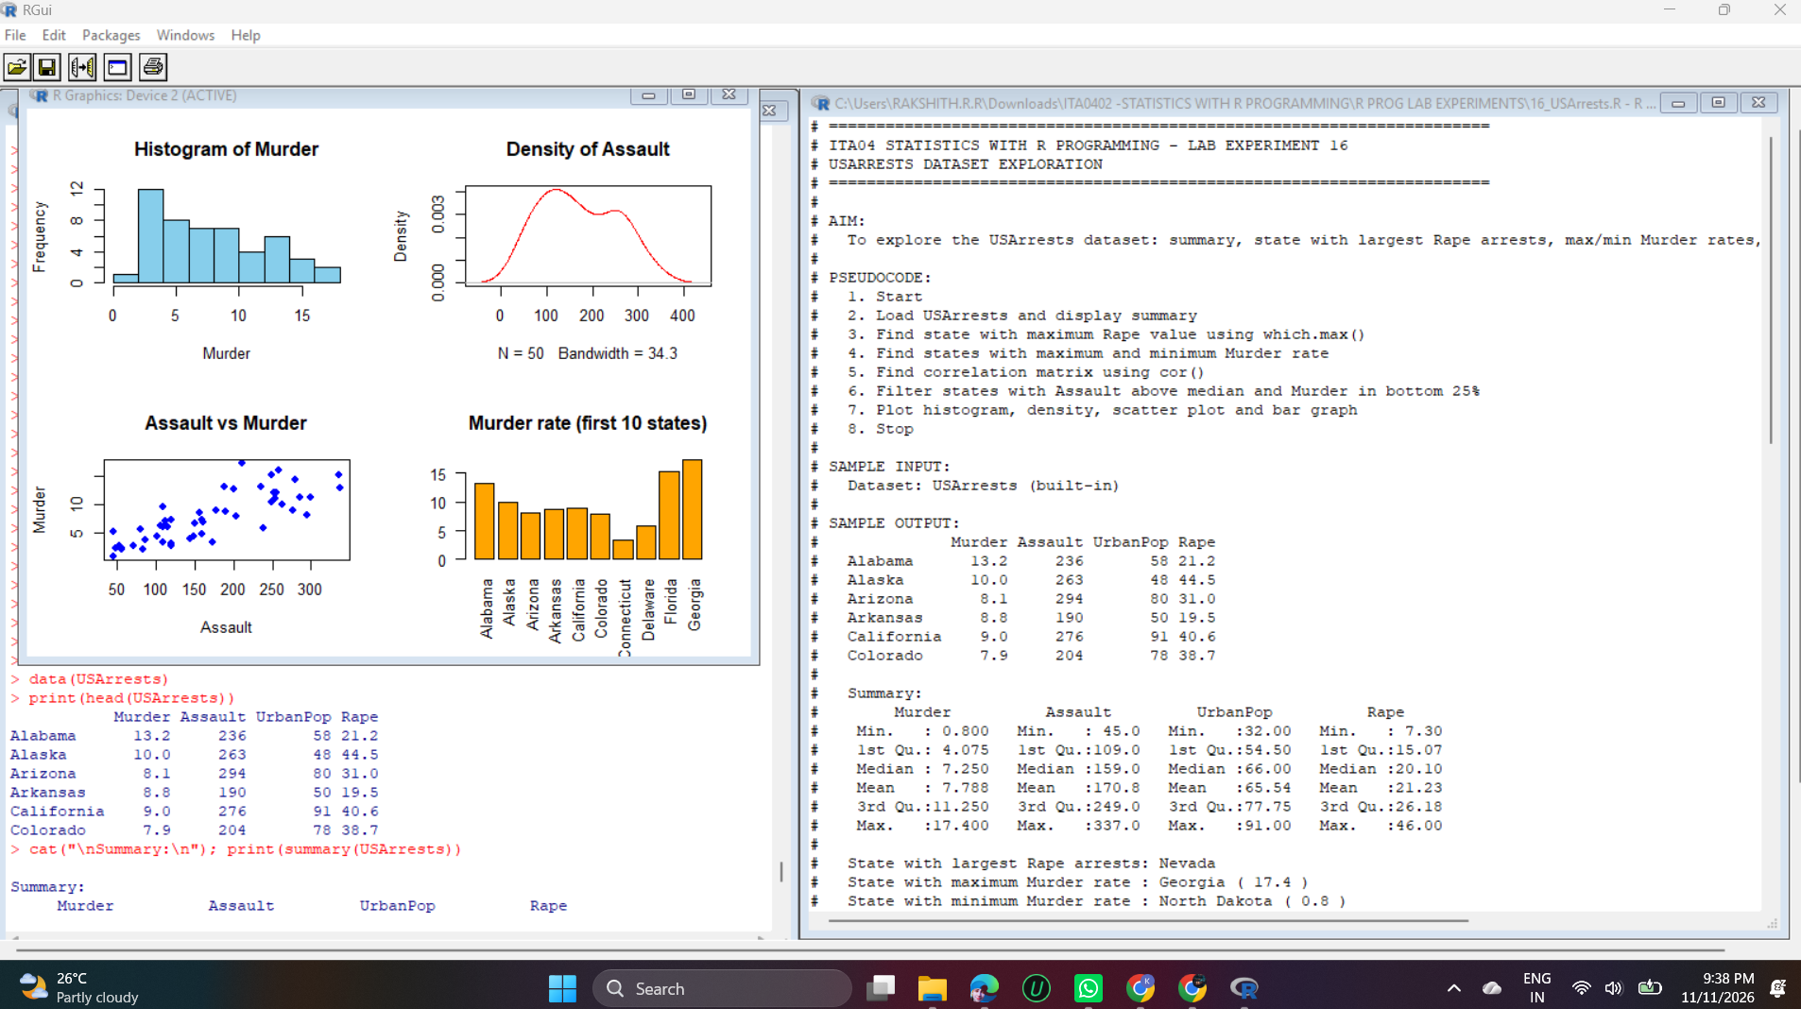
Output 1 of 2 – Experiment 16
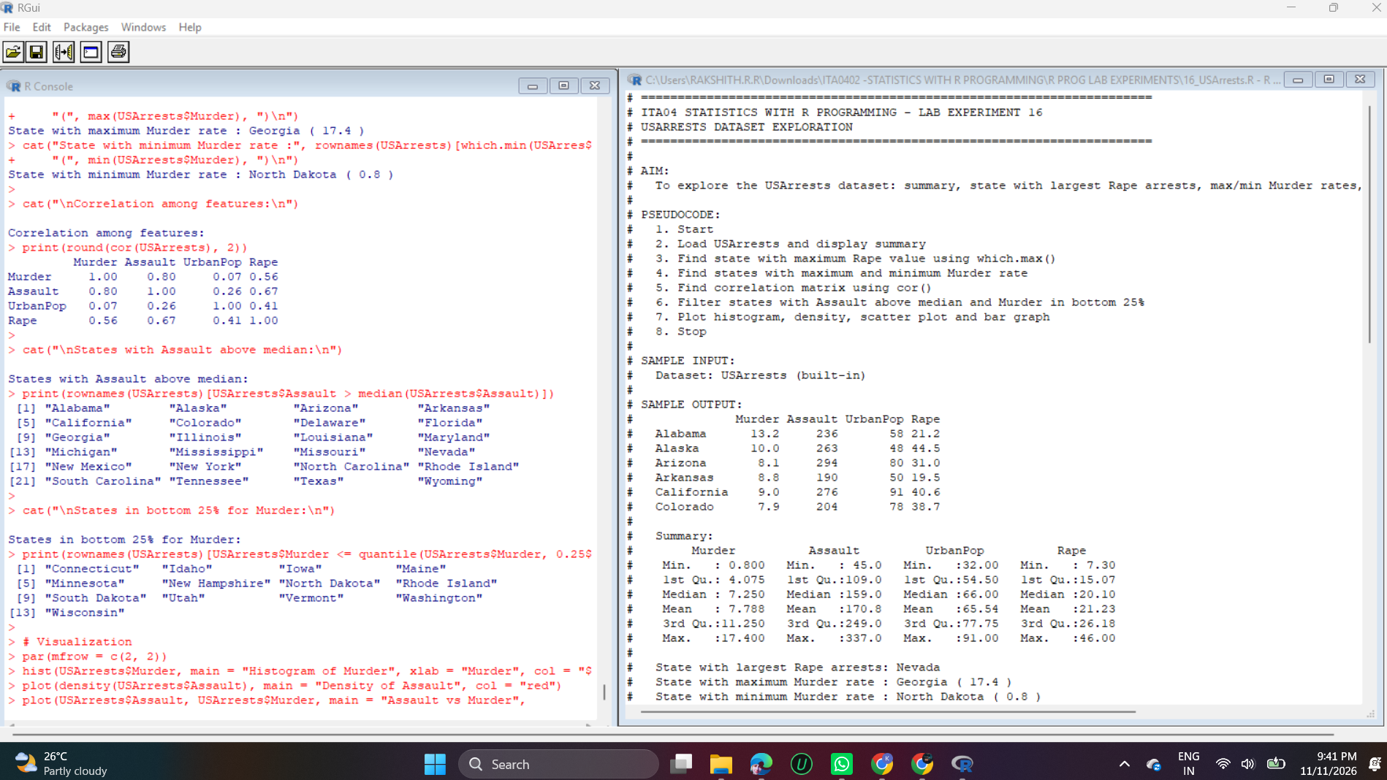
Output 2 of 2 – Experiment 16

Explanation
summary() gives the basic statistics. which.max() and which.min() return the position of the largest and smallest value, and rownames() converts that position into the state name: Nevada has the largest Rape arrests (46), Georgia the maximum Murder rate (17.4) and North Dakota the minimum (0.8).
cor() gives the correlation matrix. Murder and Assault are strongly related (0.80), while Murder and UrbanPop are almost unrelated (0.07).
Logical indexing filters the states: 24 states have an Assault value above the median (159), and 13 states fall in the bottom 25% for Murder (at or below 4.075).
The four plots show the distribution of Murder (histogram), the shape of Assault (density curve with two peaks), the positive relationship between Assault and Murder (scatter plot) and the murder rate of the first 10 states (bar graph).

Experiment 17: Titanic Dataset

Question
17. Explore Titanic dataset: bar chart of survival vs class, modify plot by gender, histogram of Age.

Code
if (file.exists("titanic.csv")) {
titanic <- read.csv("titanic.csv")
} else {
titanic <- read.csv("https://raw.githubusercontent.com/datasciencedojo/datasets/master/titanic.csv")
}
cat("Rows:", nrow(titanic), " Columns:", ncol(titanic), "\n")

# Bar chart: Survival vs Class
t1 <- table(Survived = titanic$Survived, Class = titanic$Pclass)
print(t1)
barplot(t1, beside = TRUE, col = c("tomato", "seagreen"),
main = "Survival by Passenger Class", xlab = "Class", ylab = "Passengers",
legend.text = c("Died", "Survived"))

# Modified plot: by gender
t2 <- table(Survived = titanic$Survived, Sex = titanic$Sex)
print(t2)
barplot(t2, beside = TRUE, col = c("tomato", "seagreen"),
main = "Survival by Gender", xlab = "Gender", ylab = "Passengers",
legend.text = c("Died", "Survived"))

# Histogram of Age
hist(titanic$Age, breaks = 15, col = "skyblue", main = "Histogram of Age", xlab = "Age")
cat("Mean age:", round(mean(titanic$Age, na.rm = TRUE), 2), "\n")

Output
Rows: 891 Columns: 12
Class
Survived 1 2 3
0 80 97 372
1 136 87 119
Sex
Survived female male
0 81 468
1 233 109
Mean age: 29.7

Output Screenshots
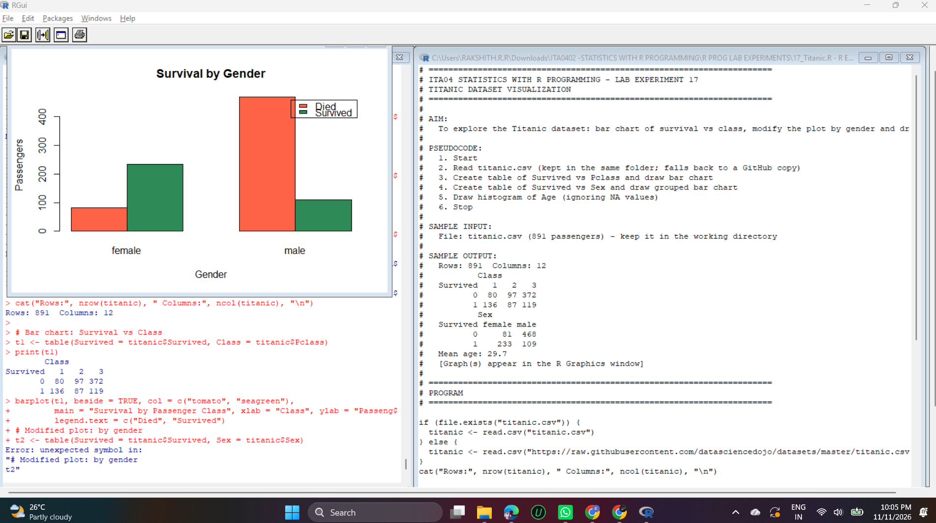
Output 1 of 2 – Experiment 17
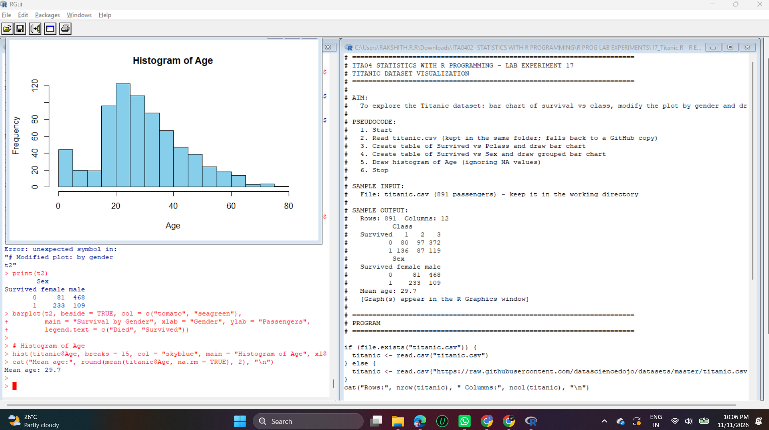
Output 2 of 2 – Experiment 17

Explanation
The program reads titanic.csv (891 passengers, 12 columns) and uses table() to count survival against class and against gender.
Survival by class: first class had 136 survivors against 80 deaths, while third class had 119 survivors against 372 deaths. Survival chances fell with class.
Survival by gender: 233 females survived and 81 died, whereas only 109 males survived and 468 died. barplot(..., beside = TRUE) draws the Died and Survived bars side by side with a legend.
The histogram of Age (missing ages ignored) shows most passengers were between 20 and 40 years old, and the mean age is 29.7 years.

Experiment 18: Basic Graphs

Question
18. Create graphs in R: boxplot, histogram, bar plot, line chart, scatter plot.

Code
par(mfrow = c(2, 3))

boxplot(mpg ~ cyl, data = mtcars, main = "Boxplot", xlab = "Cylinders",
ylab = "Mileage", col = "lightblue")

hist(mtcars$mpg, main = "Histogram", xlab = "Mileage", col = "orange")

counts <- table(mtcars$gear)
barplot(counts, main = "Bar Plot", xlab = "Gears", ylab = "Cars", col = "green")

sales <- c(20, 35, 30, 45, 60, 55)
plot(1:6, sales, type = "o", main = "Line Chart", xlab = "Month", ylab = "Sales", col = "red")

plot(mtcars$wt, mtcars$mpg, main = "Scatter Plot", xlab = "Weight", ylab = "Mileage",
pch = 19, col = "blue")

par(mfrow = c(1, 1))
cat("Five graphs created.\n")

Output
Five graphs created.

Output Screenshot
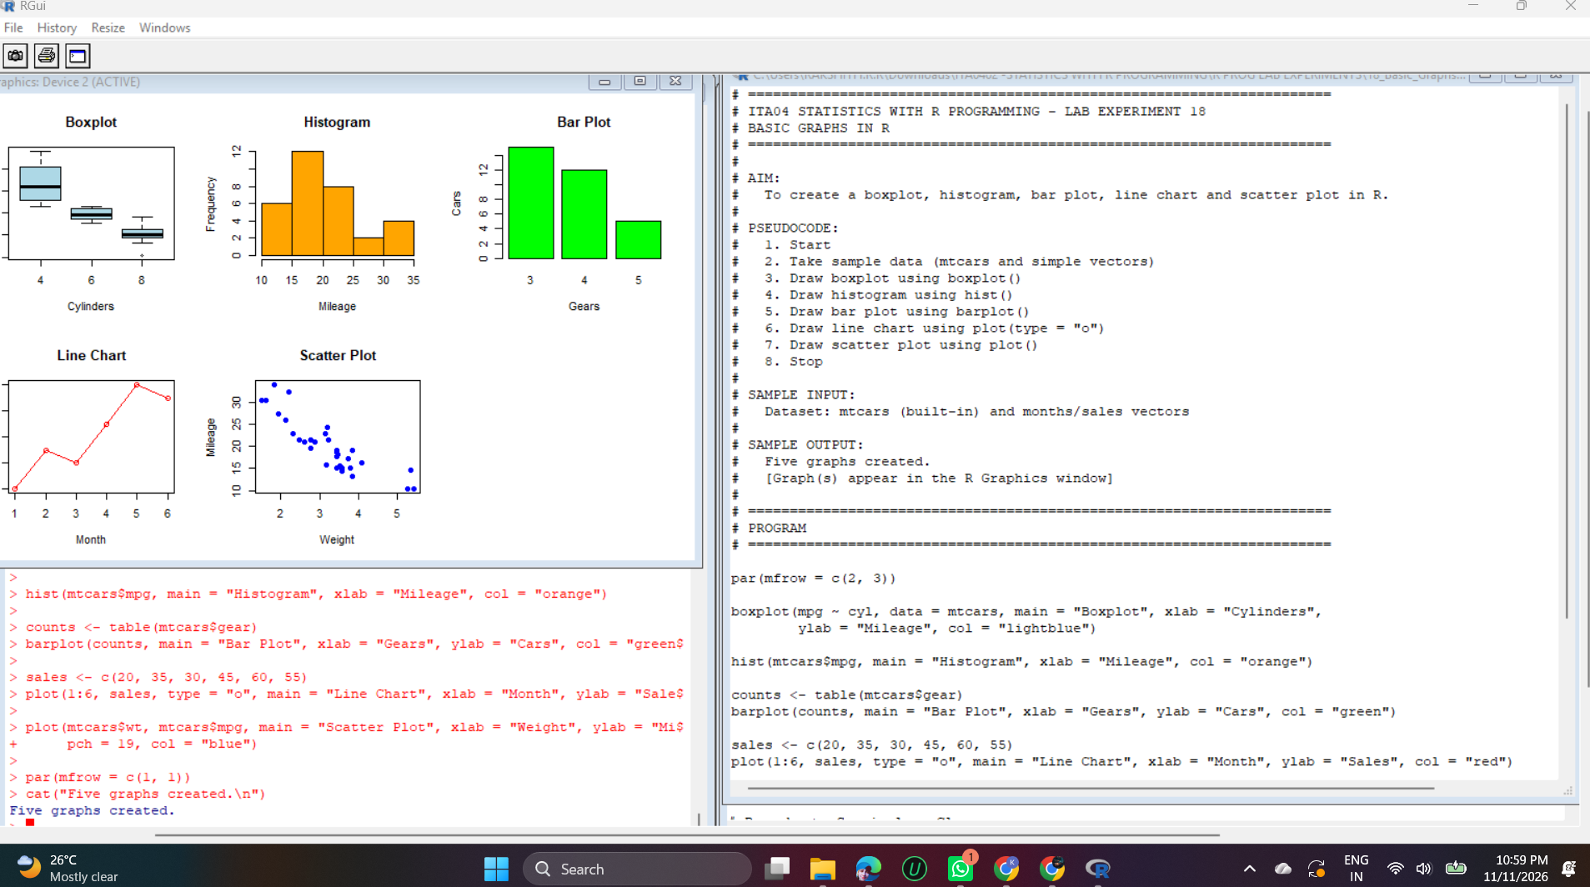
Output – Experiment 18

Explanation
par(mfrow = c(2, 3)) creates a grid of 2 rows and 3 columns so that five graphs can be shown in one window.
The boxplot compares mileage for 4, 6 and 8 cylinders (mileage falls as cylinders increase). The histogram shows the distribution of mileage, with most cars between 15 and 25 mpg. The bar plot counts cars by number of gears (3 gears is most common).
The line chart plots sales over six months with plot(type = "o"), and the scatter plot shows that heavier cars have lower mileage (a negative relationship).

Experiment 19: Simple Linear Regression

Question
19. Build a regression model on advertising dataset (Sales ~ Spend) and predict Sales.

Code
advertising <- data.frame(
Spend = c(10, 20, 30, 40, 50, 60, 70, 80, 90, 100),
Sales = c(25, 32, 41, 48, 57, 66, 71, 82, 90, 98)
)

model <- lm(Sales ~ Spend, data = advertising)
print(summary(model))

cat("\nCoefficients:\n")
print(coef(model))

new_data <- data.frame(Spend = 120)
pred <- predict(model, new_data)
cat("\nPredicted Sales for Spend = 120 :", round(pred, 2), "\n")

plot(advertising$Spend, advertising$Sales, pch = 19, col = "blue",
main = "Sales vs Spend", xlab = "Spend", ylab = "Sales")
abline(model, col = "red", lwd = 2)

Output

Call:
lm(formula = Sales ~ Spend, data = advertising)

Residuals:
Min 1Q Median 3Q Max
-2.2364 -0.3167 0.3424 0.5667 0.9212

Coefficients:
Estimate Std. Error t value Pr(>|t|)
(Intercept) 16.13333 0.68106 23.69 1.07e-08 ***
Spend 0.81576 0.01098 74.32 1.20e-12 ***
---
Signif. codes: 0 ‘***’ 0.001 ‘**’ 0.01 ‘*’ 0.05 ‘.’ 0.1 ‘ ’ 1

Residual standard error: 0.997 on 8 degrees of freedom
Multiple R-squared: 0.9986, Adjusted R-squared: 0.9984
F-statistic: 5524 on 1 and 8 DF, p-value: 1.197e-12

Coefficients:
(Intercept) Spend
16.1333333 0.8157576

Predicted Sales for Spend = 120 : 114.02

Output Screenshots
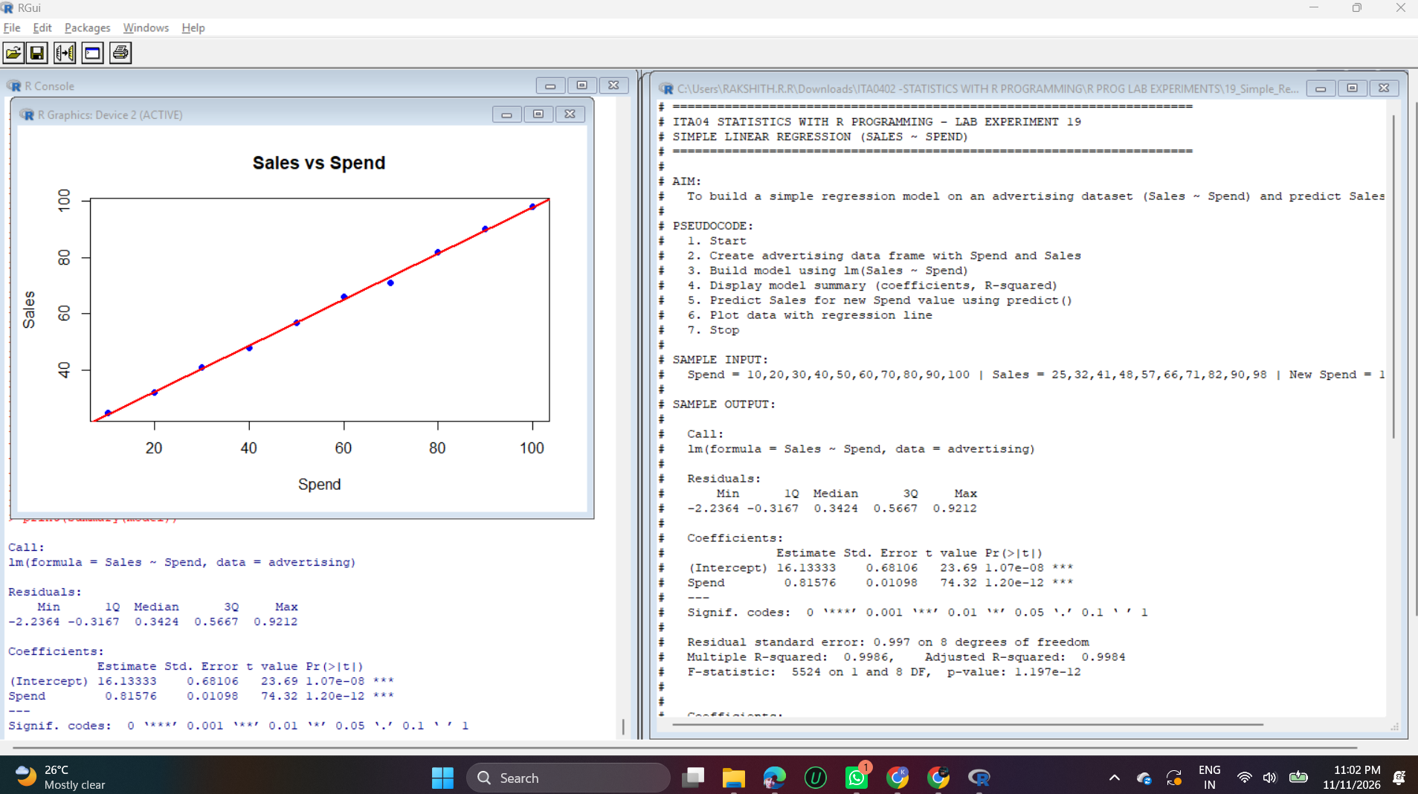
Output 1 of 2 – Experiment 19
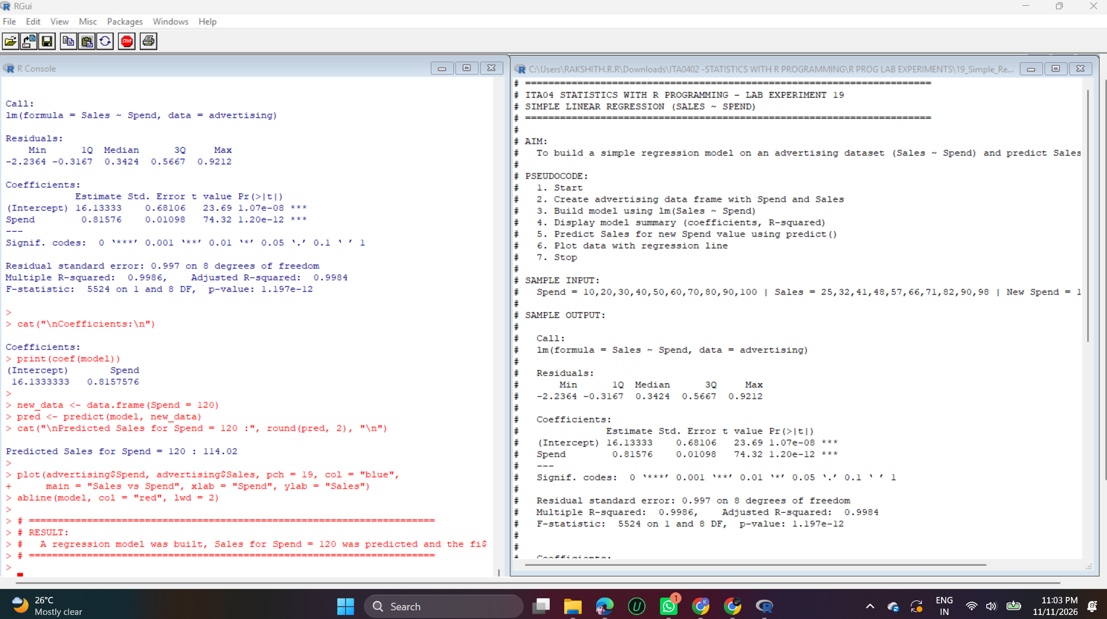
Output 2 of 2 – Experiment 19

Explanation
lm(Sales ~ Spend) fits a simple linear regression of Sales on Spend. The fitted equation is Sales = 16.13 + 0.8158 × Spend, so each unit increase in Spend raises Sales by about 0.82.
Multiple R-squared is 0.9986, so the model explains 99.86% of the variation in Sales, and the p-value (1.2e-12) shows that Spend is highly significant.
predict() applies the model to a new Spend of 120 and returns Sales = 16.13 + 0.8158 × 120 = 114.02. The scatter plot with abline() shows the points lying very close to the red regression line.

Experiment 20: Multiple Regression

Question
20. Create multiple regression model using ChickWeight dataset with “Time” and “Diet” as predictors; predict weight and compute model error.

Code
cw <- as.data.frame(ChickWeight)

model <- lm(weight ~ Time + Diet, data = cw)
print(summary(model))

# Prediction for a new chick
new_chick <- data.frame(Time = 10, Diet = factor("1", levels = levels(cw$Diet)))
cat("\nPredicted weight (Time=10, Diet=1):", round(predict(model, new_chick), 2), "\n")

# Model error
pred <- predict(model, cw)
error <- cw$weight - pred
rmse <- sqrt(mean(error^2))
mae <- mean(abs(error))

cat("\nRMSE :", round(rmse, 2), "\n")
cat("MAE :", round(mae, 2), "\n")
cat("R-squared:", round(summary(model)$r.squared, 4), "\n")

Output

Call:
lm(formula = weight ~ Time + Diet, data = cw)

Residuals:
Min 1Q Median 3Q Max
-136.851 -17.151 -2.595 15.033 141.816

Coefficients:
Estimate Std. Error t value Pr(>|t|)
(Intercept) 10.9244 3.3607 3.251 0.00122 **
Time 8.7505 0.2218 39.451 < 2e-16 ***
Diet2 16.1661 4.0858 3.957 8.56e-05 ***
Diet3 36.4994 4.0858 8.933 < 2e-16 ***
Diet4 30.2335 4.1075 7.361 6.39e-13 ***
---
Signif. codes: 0 ‘***’ 0.001 ‘**’ 0.01 ‘*’ 0.05 ‘.’ 0.1 ‘ ’ 1

Residual standard error: 35.99 on 573 degrees of freedom
Multiple R-squared: 0.7453, Adjusted R-squared: 0.7435
F-statistic: 419.2 on 4 and 573 DF, p-value: < 2.2e-16

Predicted weight (Time=10, Diet=1): 98.43

RMSE : 35.84
MAE : 25
R-squared: 0.7453

Output Screenshot
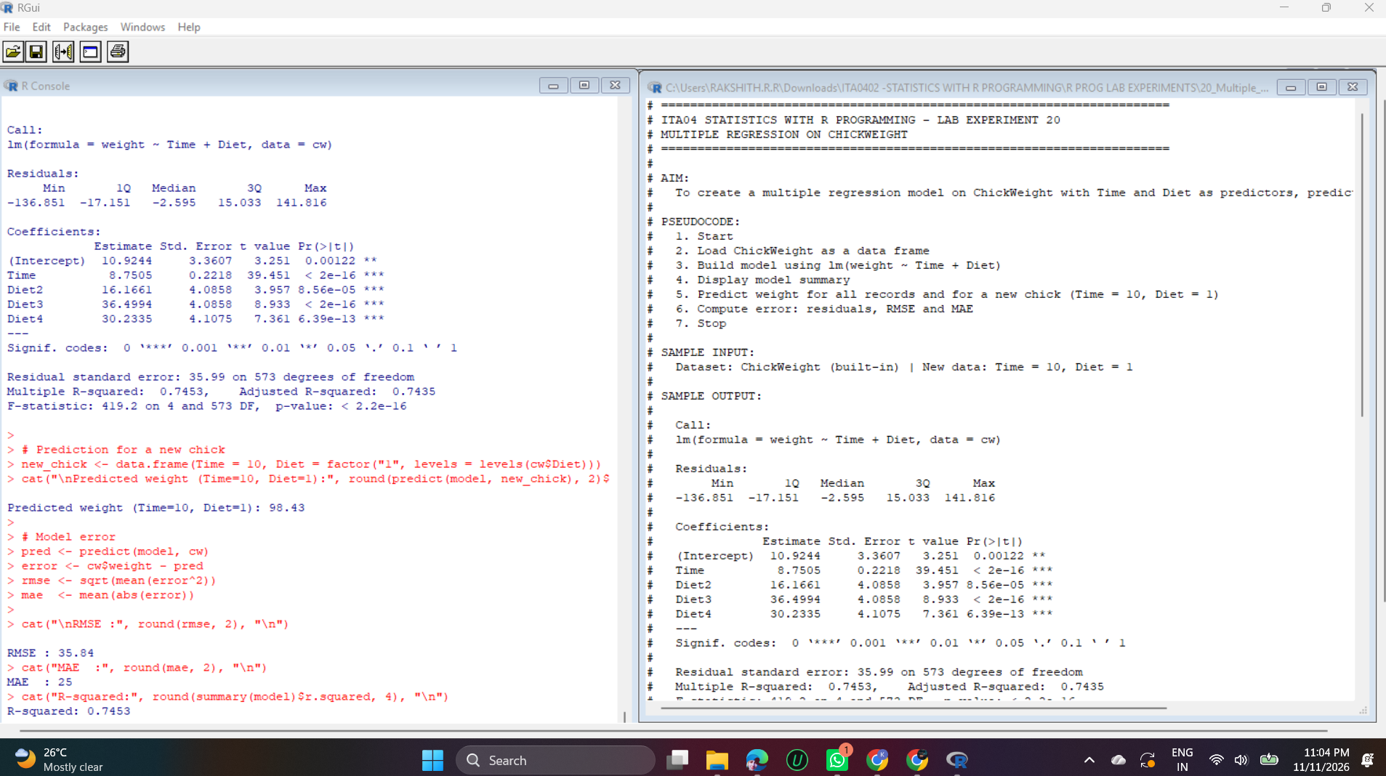
Output – Experiment 20

Explanation
lm(weight ~ Time + Diet) uses two predictors. Diet is a factor, so R creates the dummy variables Diet2, Diet3 and Diet4 and treats Diet 1 as the baseline.
The coefficient of Time (8.75) means a chick gains about 8.75 g per day. Compared with Diet 1, Diet 2 adds 16.2 g, Diet 3 adds 36.5 g (the best diet) and Diet 4 adds 30.2 g. Multiple R-squared is 0.7453, so the model explains about 74.5% of the variation.
The prediction for Time = 10 and Diet = 1 is 10.92 + 8.75 × 10 = 98.43 g.
Model error: RMSE = 35.84 g and MAE = 25 g. On average the predictions differ from the actual weights by about 25 g, and RMSE is larger because it penalises large errors more.

Experiment 21: Logistic Regression on iris

Question
21. Randomly split iris dataset into train/test (80/20), build logistic regression (Species ~ Petal.Length + Petal.Width), predict, and evaluate with confusion matrix.

Code
# NOTE: glm(family = binomial) works only for 2 classes. Iris has 3 species,
# so multinomial logistic regression (nnet::multinom) is used.
library(nnet)

set.seed(123)
idx <- sample(1:nrow(iris), 0.8 * nrow(iris))
train <- iris[idx, ]
test <- iris[-idx, ]
cat("Training rows:", nrow(train), " Testing rows:", nrow(test), "\n")

model <- multinom(Species ~ Petal.Length + Petal.Width, data = train, trace = FALSE)
print(summary(model)$coefficients)

pred <- predict(model, test)

cm <- table(Actual = test$Species, Predicted = pred)
cat("\nConfusion Matrix:\n")
print(cm)

accuracy <- sum(diag(cm)) / sum(cm)
cat("\nAccuracy:", round(accuracy * 100, 2), "%\n")

Output
Training rows: 120 Testing rows: 30
(Intercept) Petal.Length Petal.Width
versicolor -22.80429 6.592006 8.275971
virginica -68.83031 12.810970 18.028532

Confusion Matrix:
Predicted
Actual setosa versicolor virginica
setosa 10 0 0
versicolor 0 14 1
virginica 0 0 5

Accuracy: 96.67 %

Output Screenshot
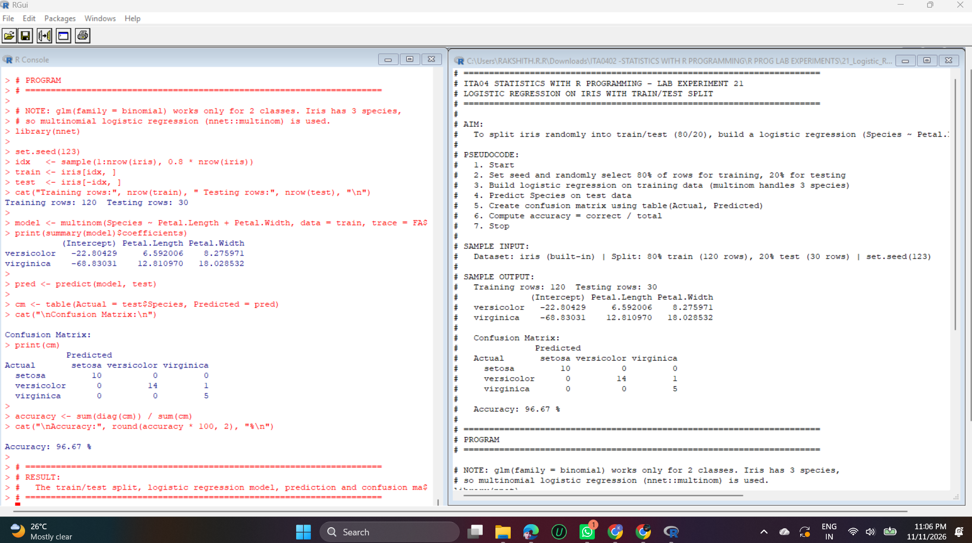
Output – Experiment 21

Explanation
set.seed(123) makes the random split repeatable. sample() picks 80% of the row numbers (120 rows) for training and the remaining 30 rows are used for testing.
glm(family = binomial) works only for two classes, and iris has three species, so multinomial logistic regression (nnet::multinom) is used with Petal.Length and Petal.Width as predictors. The coefficients are given for versicolor and virginica relative to setosa.
predict() classifies the test data, and table(Actual, Predicted) forms the confusion matrix. The diagonal values (10, 14, 5) are correct predictions, and only one versicolor flower was wrongly predicted as virginica.
Accuracy = (10 + 14 + 5) / 30 = 96.67%, so the model separates the three species very well.

